**Miller Creek and Vogel Lake Water Quality**

*Benjamin Meyer (*[*ben@kenaiwatershed.org*](mailto:ben@kenaiwatershed.org)*)*

*2022-10-10*

***Note: This document is best accessed in its original interactive online format, available at*** [***https://bookdown.org/kwfwqx/miller_creek_vogel_lake_wqx/***](https://bookdown.org/kwfwqx/miller_creek_vogel_lake_wqx/%20)

Contents

1 Introduction 2

2 Lake Water Quality Profiles 3

3 Miller Creek Discharge & Flow Rate 19

4 Watershed Mapping 26

5 Fish Rescue 28

6 Rotenone monitoring 34

7 Hydrolab Data 40

8 Discussion and Acknowledgements 41

# 1 Introduction

This draft document contains preliminary data explorations of 2021-2023 water quality data from the Vogel Lakes complex and Miller Creek in the Northern Kenai peninsula. These data were collected as part of plans to eradicate invasive pike from the area, which were identified in 2018-2019 by the Alaska Dept. of Fish and Game.

The draft environmental assessment for potential eradication of invasive Northern Pike from this system is available from the [US Fish and Wildlife Service](https://www.fws.gov/uploadedFiles/Region_7/NWRS/Zone_2/Kenai/PDF/Draft%20EA%20Northern%20Pike%20KNWR.pdf).

Water quality and watershed characterization fieldwork for this project is conducted by [Kenai Watershed Forum](https://www.kenaiwatershed.org/).

An ArcGIS Online map of sites included in water quality monitoring efforts is found here: <https://arcg.is/0fqvb0>.

A [GitHub repository](https://github.com/Kenai-Watershed-Forum/Miller_Creek_Vogel_Lake_WQX) with the code generating this report is also available at <https://github.com/Kenai-Watershed-Forum/Miller_Creek_Vogel_Lake_WQX>.

# 2 Lake Water Quality Profiles

Lake water quality profiles were collected at generally 1-2 month intervals at five sites at 1 meter depth intervals. Hydrolab MS5 sondes were descended from an anchored boat centered over the deepest point of each lake, and parameter values were recorded from a handheld reader once stabilized after 30-60 seconds.

Raw water quality field data is stored in a Google Sheet that can be viewed at <https://tinyurl.com/kwf-vogel-wqx-data>.

Data visualizations are provided for each site visit here.

## 2.1 Data by Month

### 2.1.1 January 2021

Jan 22, 2021

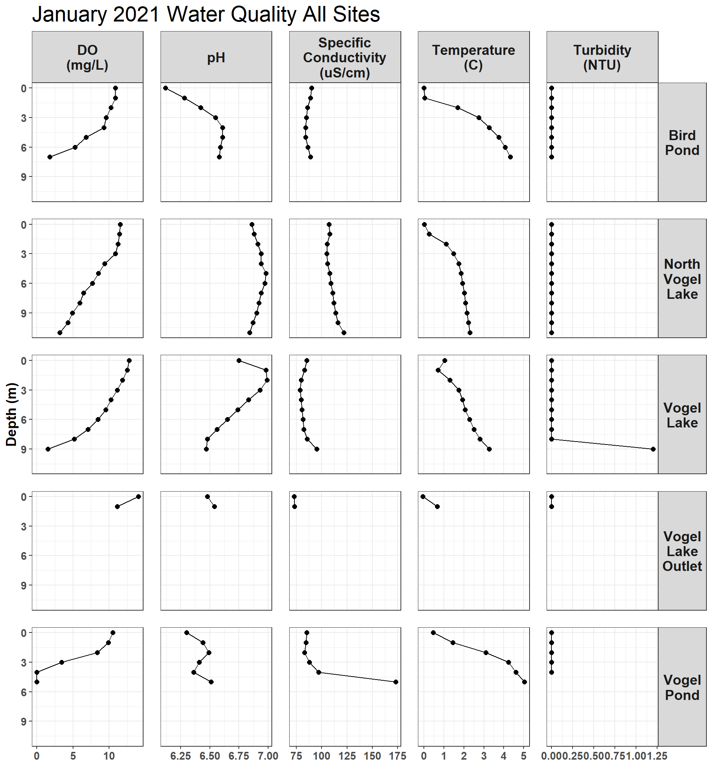

Figure 2.1: January 2021

### 2.1.2 March 2021

March 23, 2021

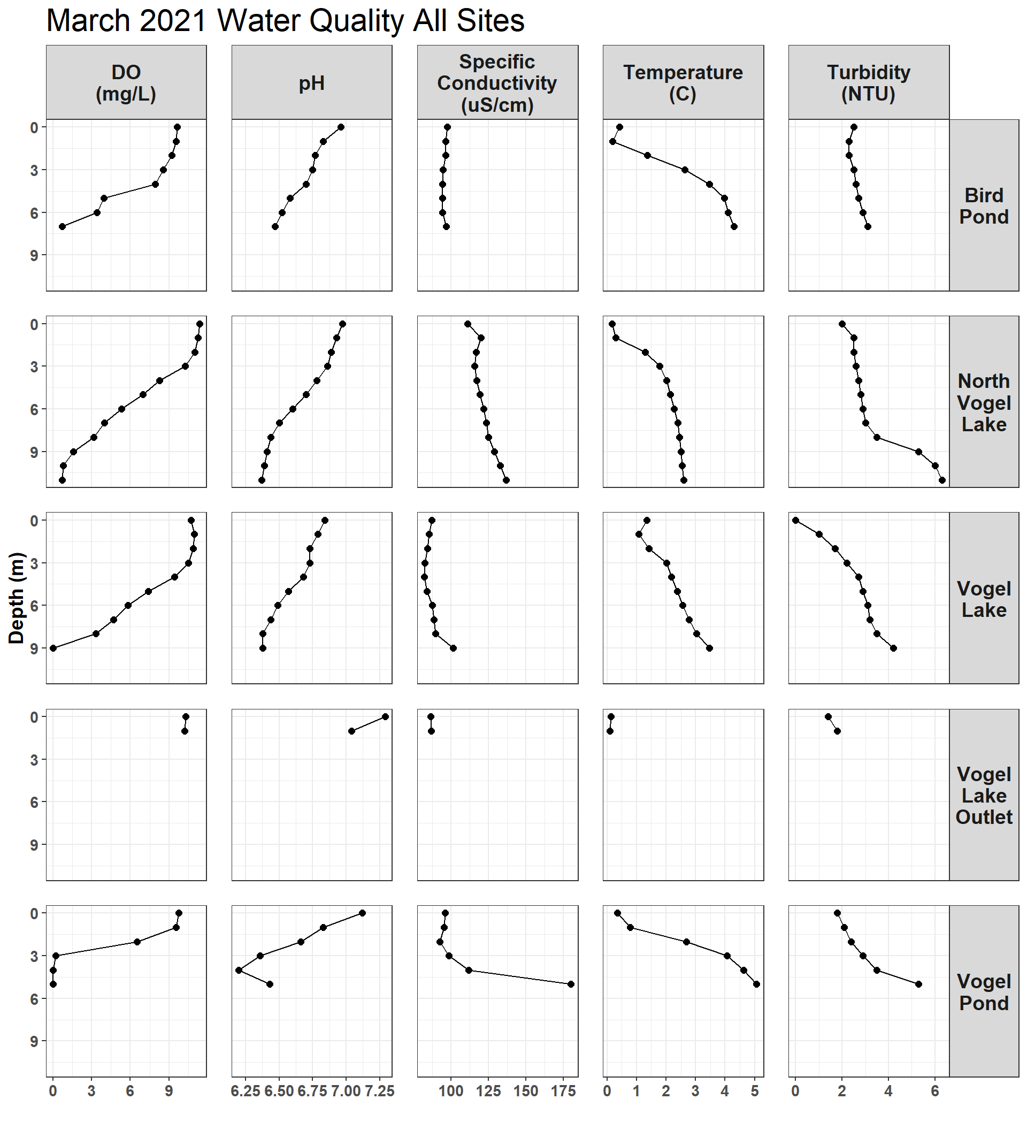

Figure 2.2: March 2021

### 2.1.3 May 2021

May 25, 2021

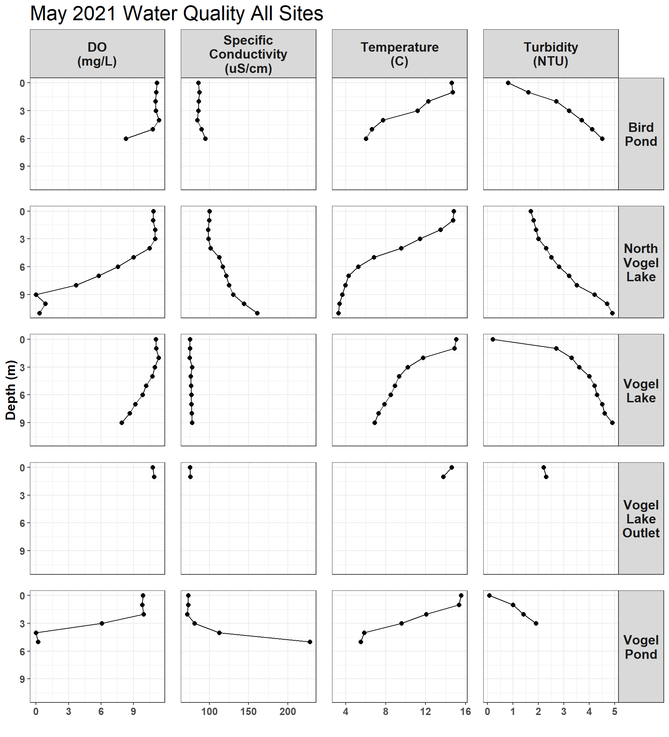

Figure 2.3: May 2021

### 2.1.4 June 2021

June 29, 2021

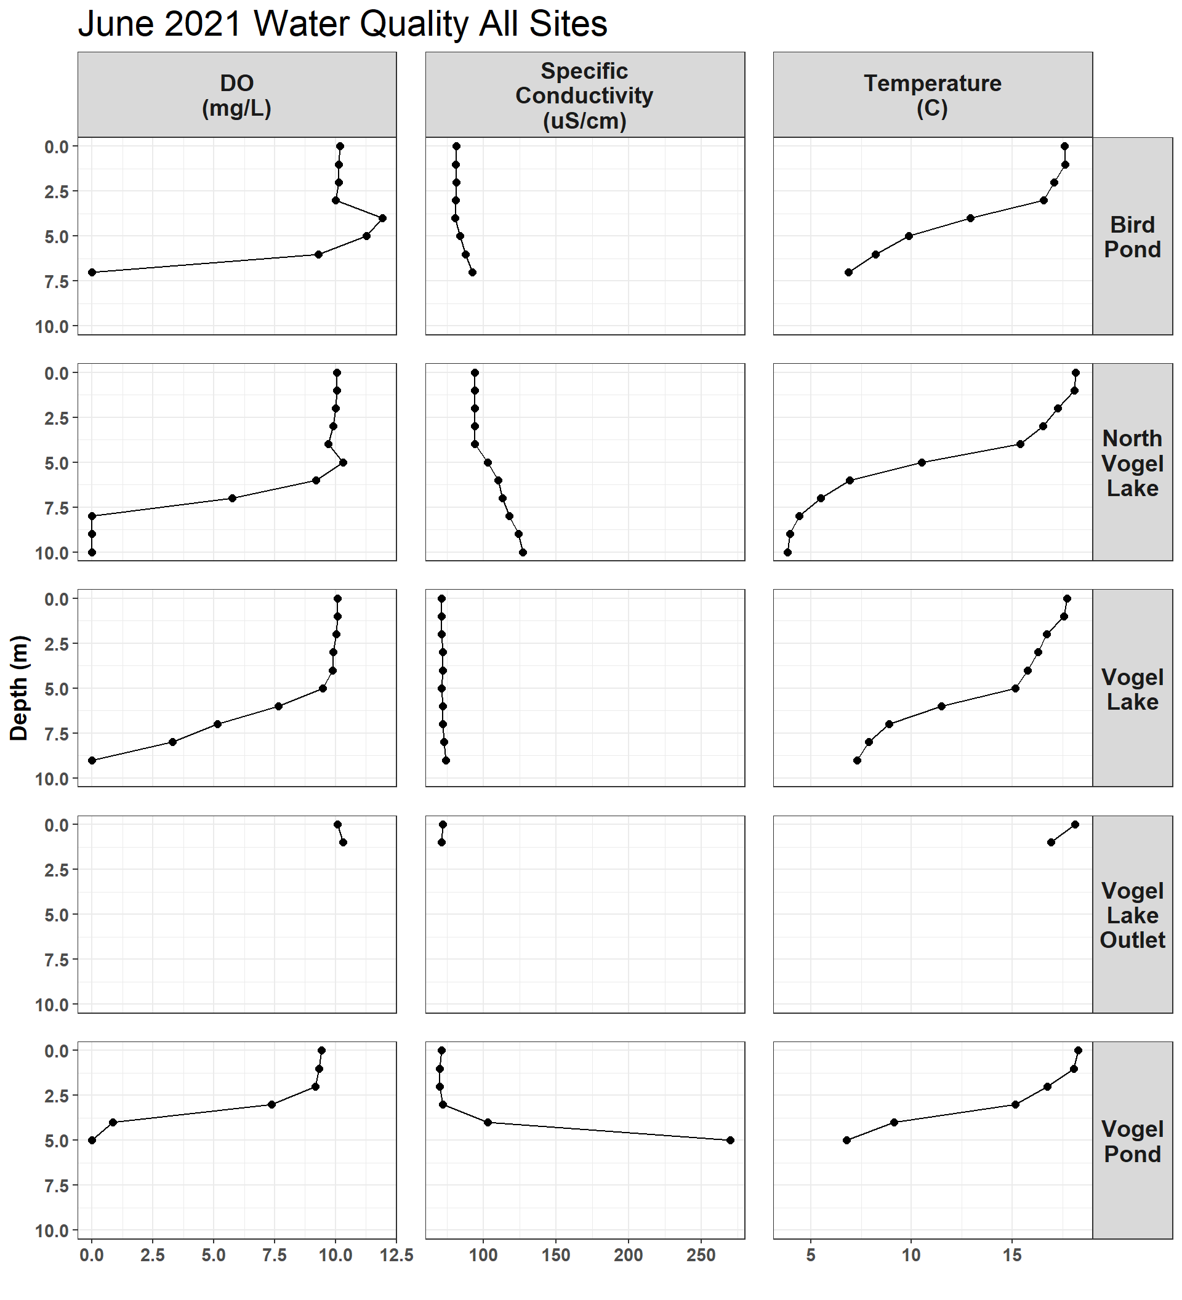

Figure 2.4: June 2021

Note: turbidity data is absent from June 2021 sampling due to an equipment issue.

### 2.1.5 August 2021

August 3, 2021

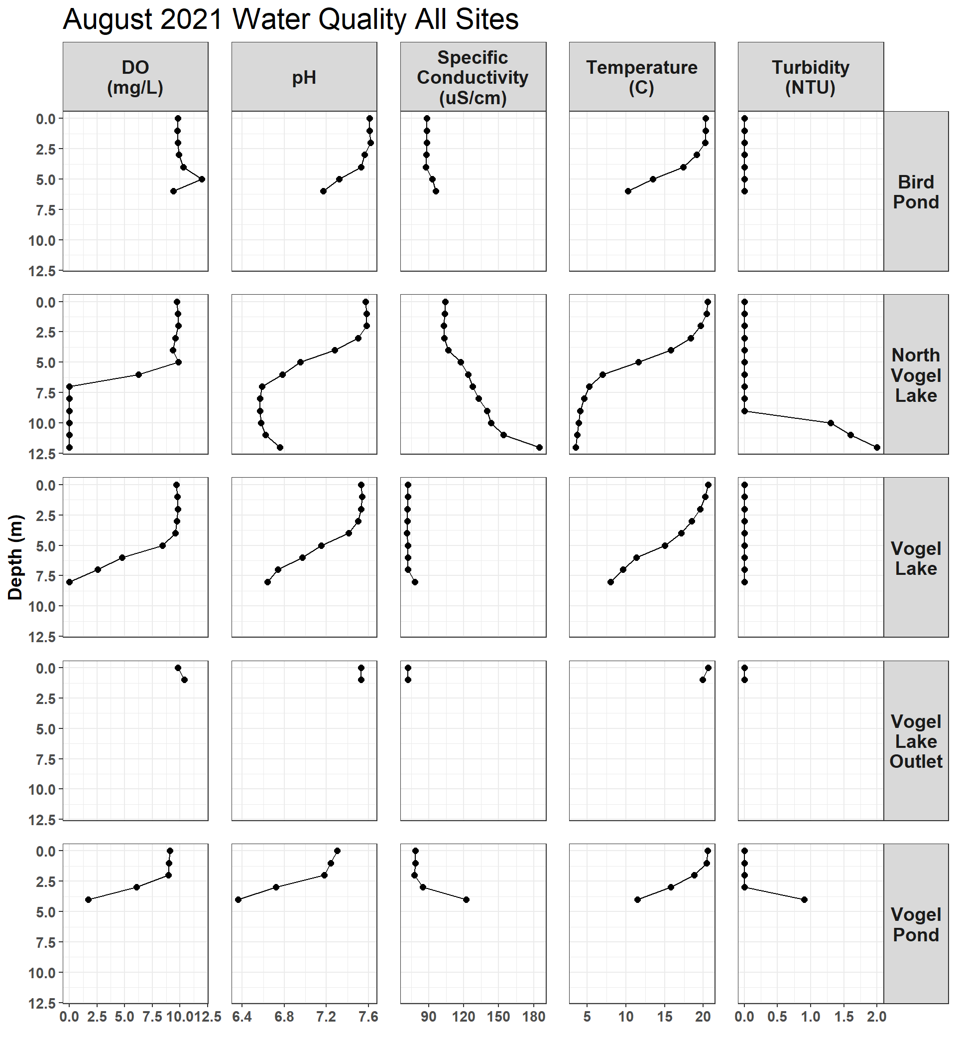

Figure 2.5: August 2021

### 2.1.6 September 2021

September 15, 2021

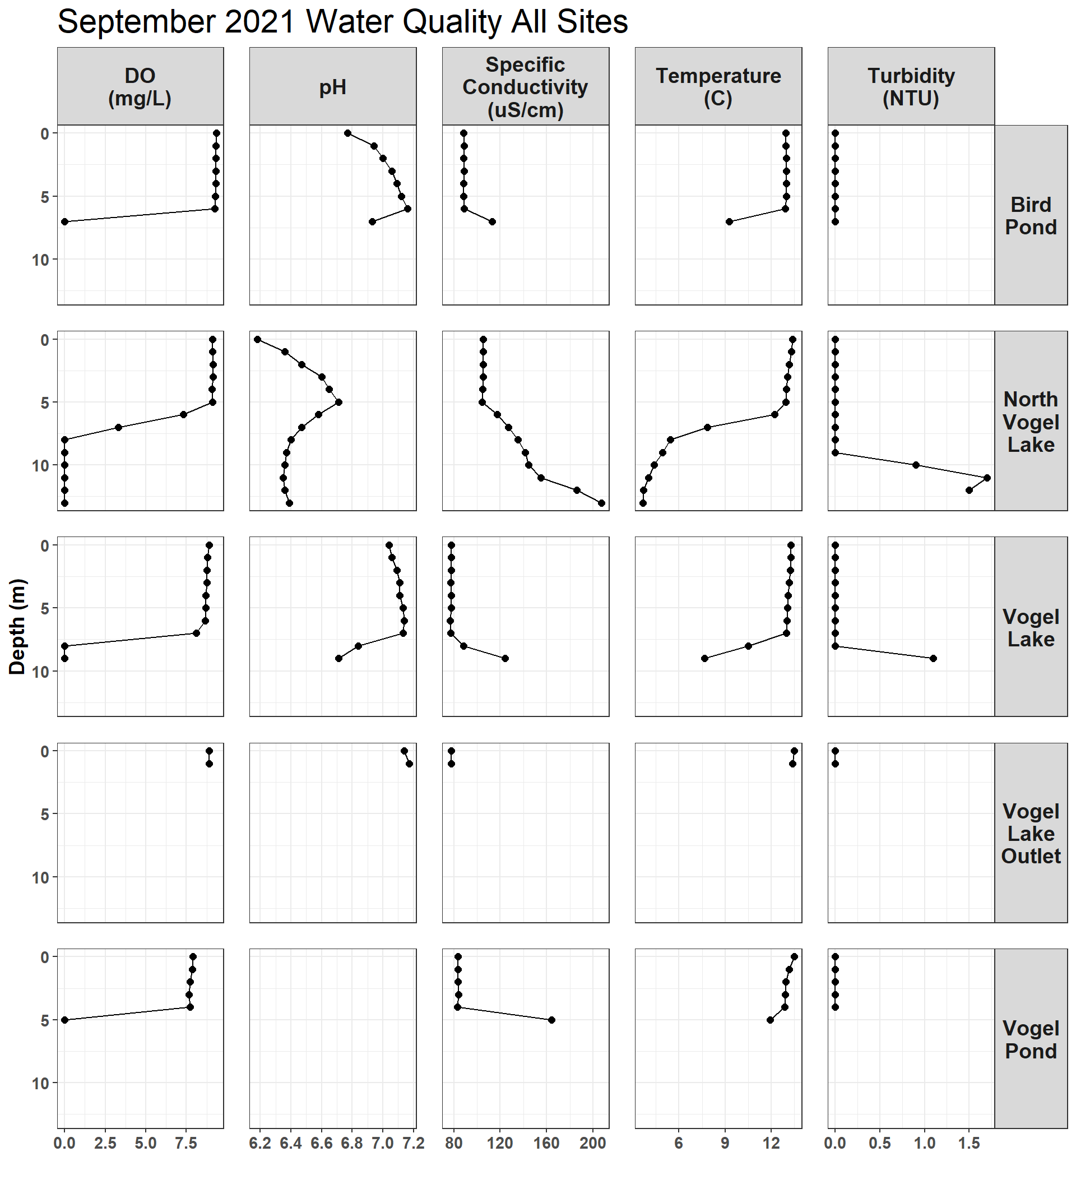

Figure 2.6: September 2021

### 2.1.7 December 2021

December 2 and 3, 2021

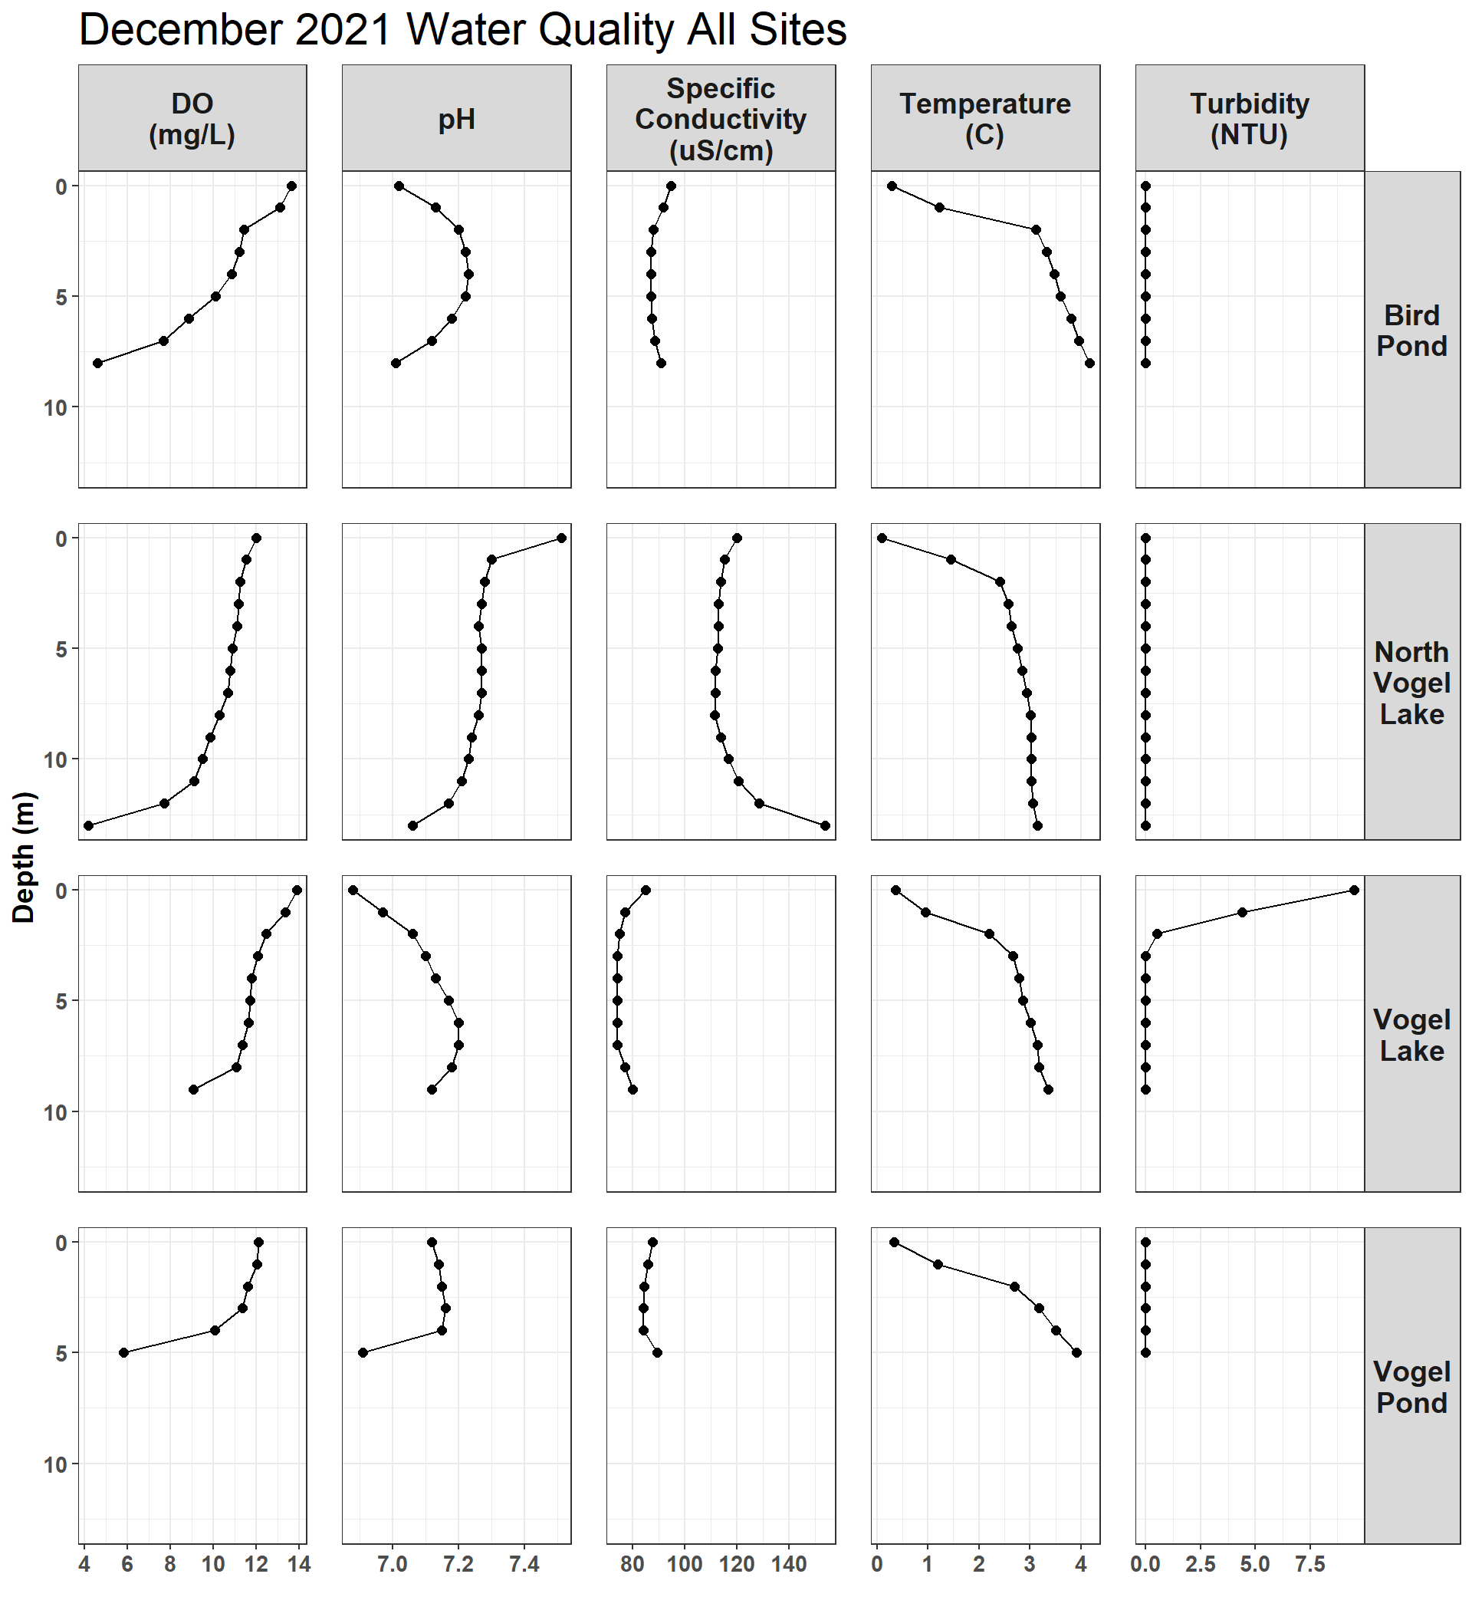

Figure 2.7: December 2021

### 2.1.8 January 2022

January 4, 5, and 6, 2022

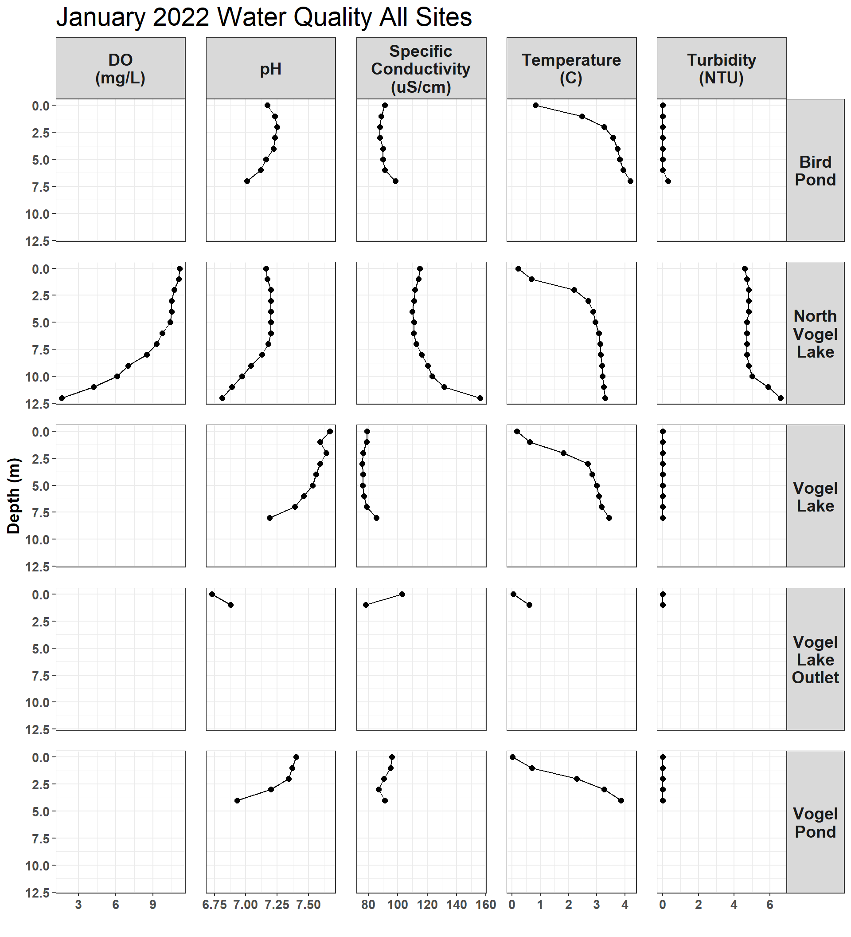

Figure 2.8: January 2022

### 2.1.9 March 2022

March 11, 12, and 13, 2022

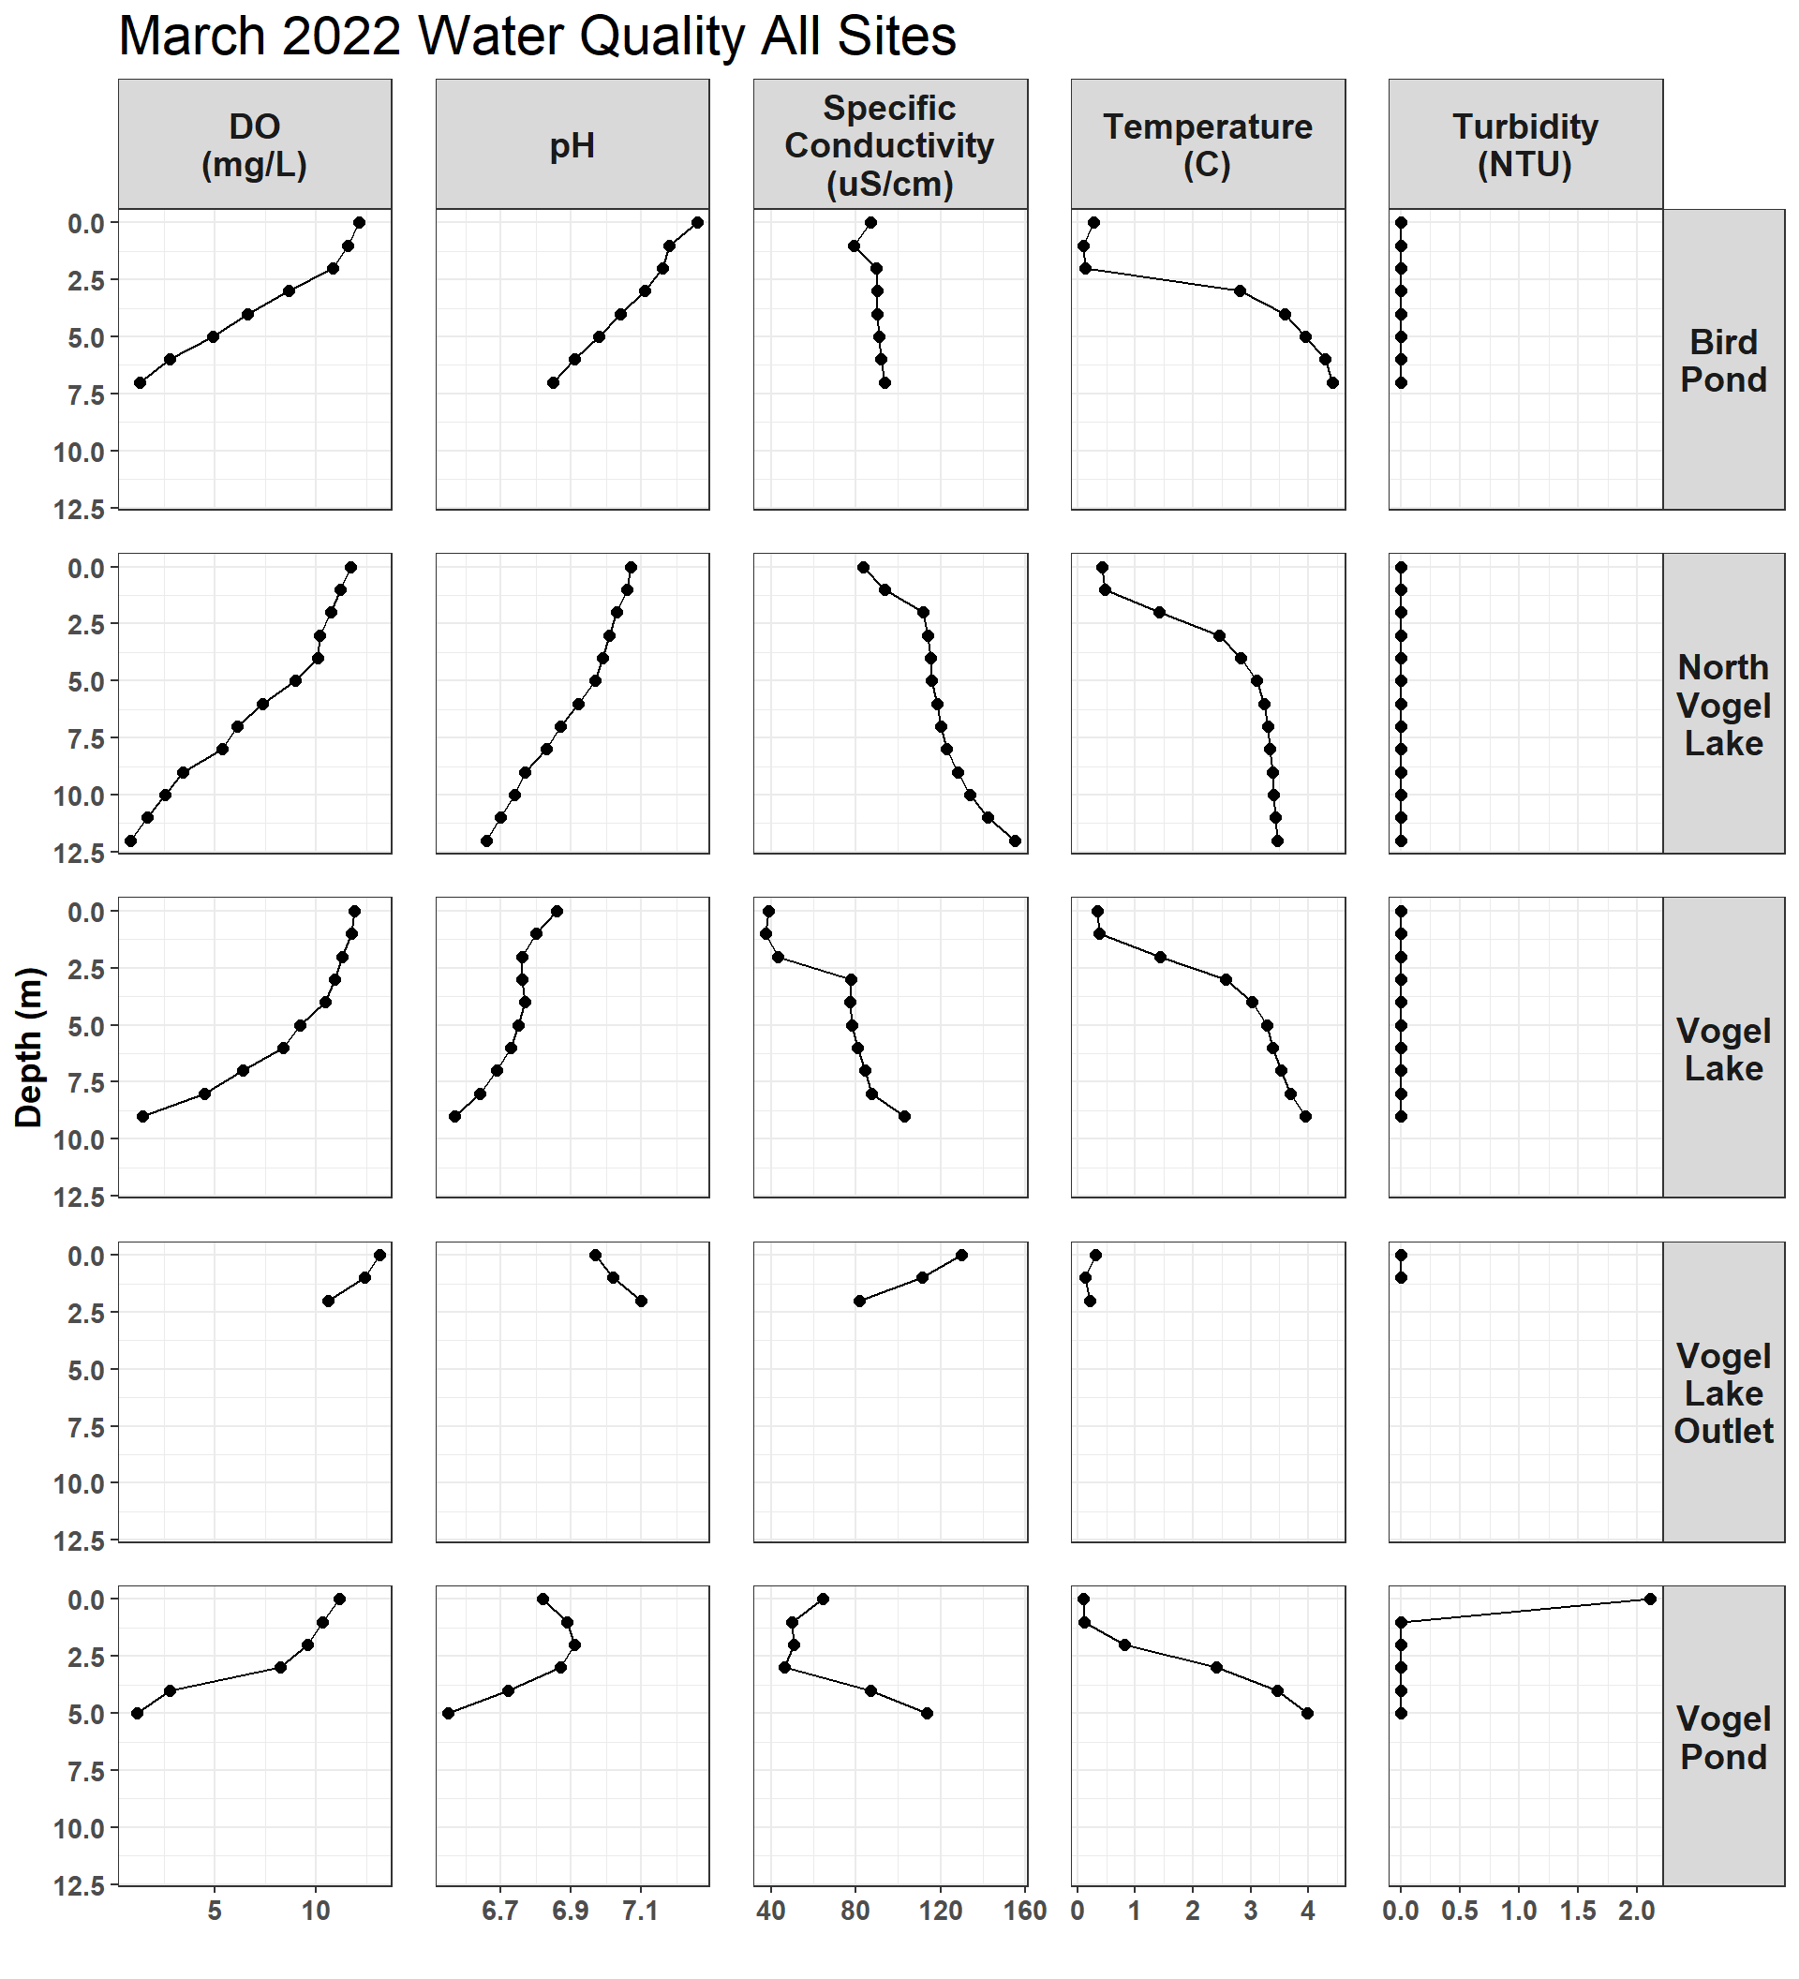

Figure 2.9: March 2022

### 2.1.10 June 2022

June 16 and 17, 2022

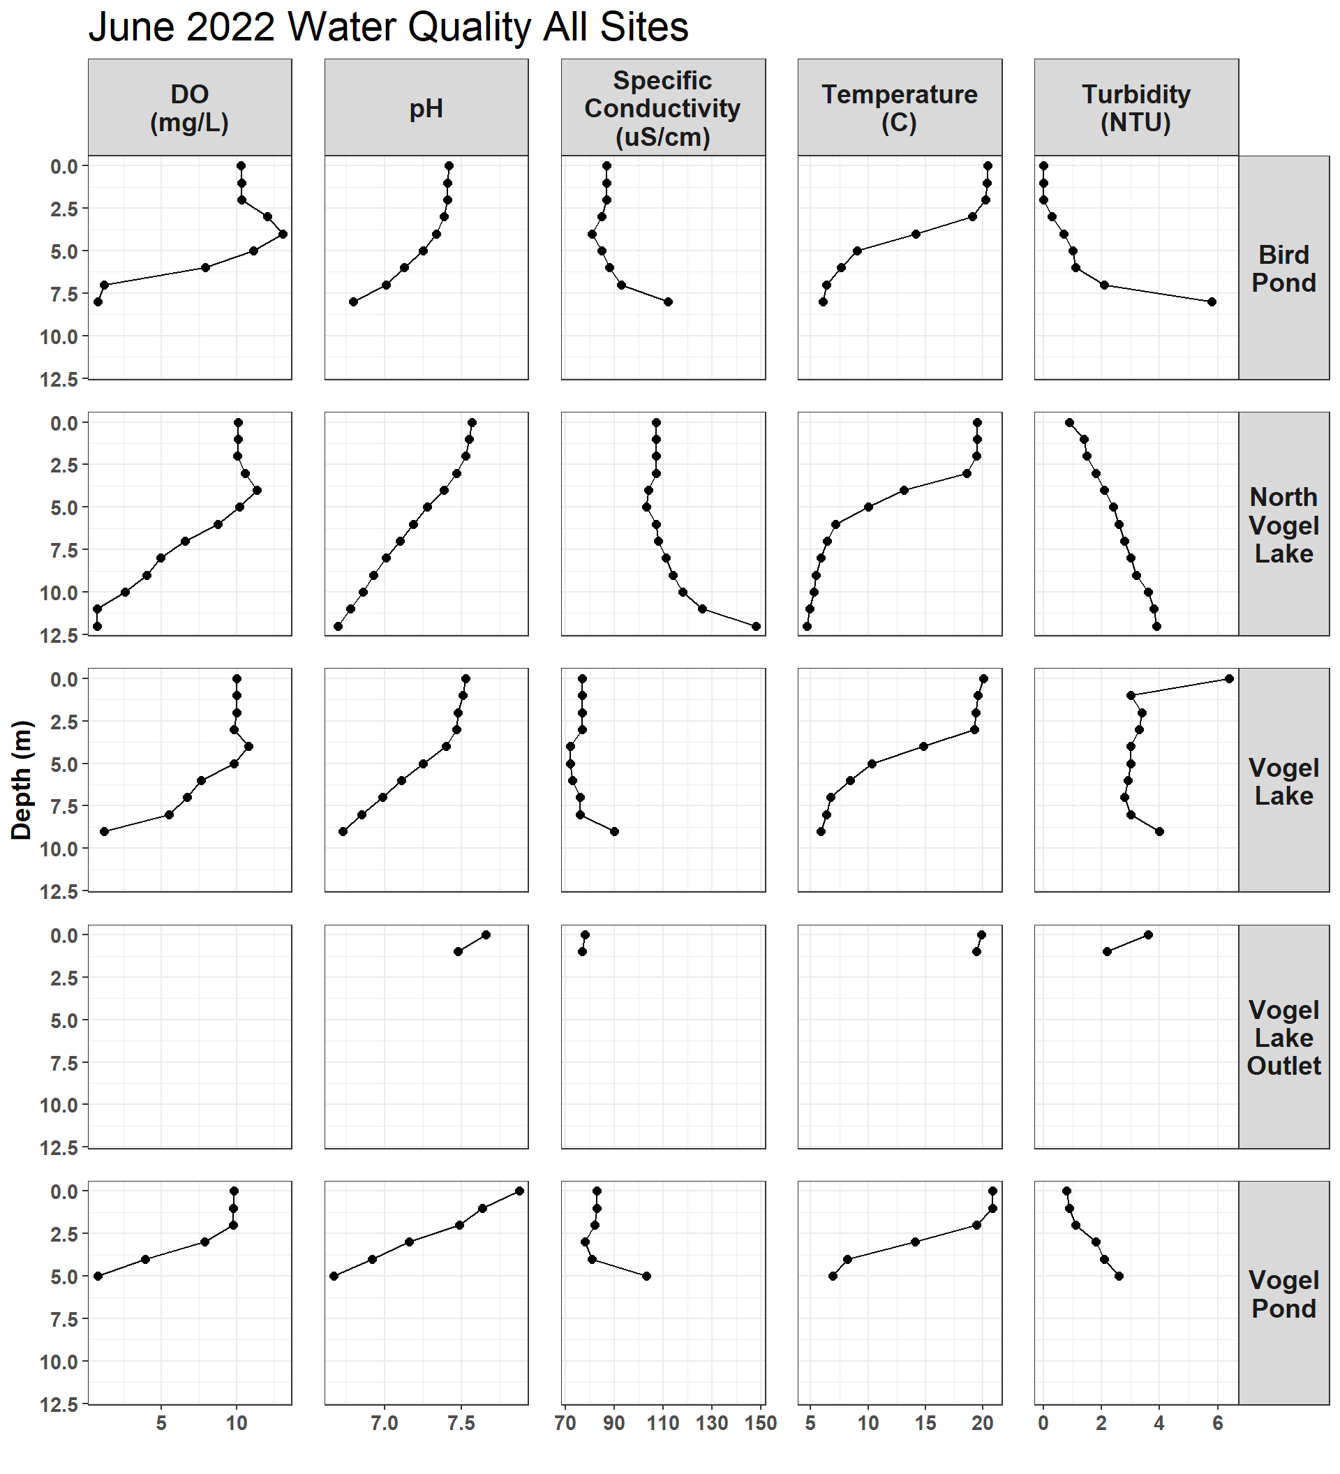

Figure 2.10: June 2022

## 2.2 Overall Data

#### 2.2.0.1 Dissolved Oxygen

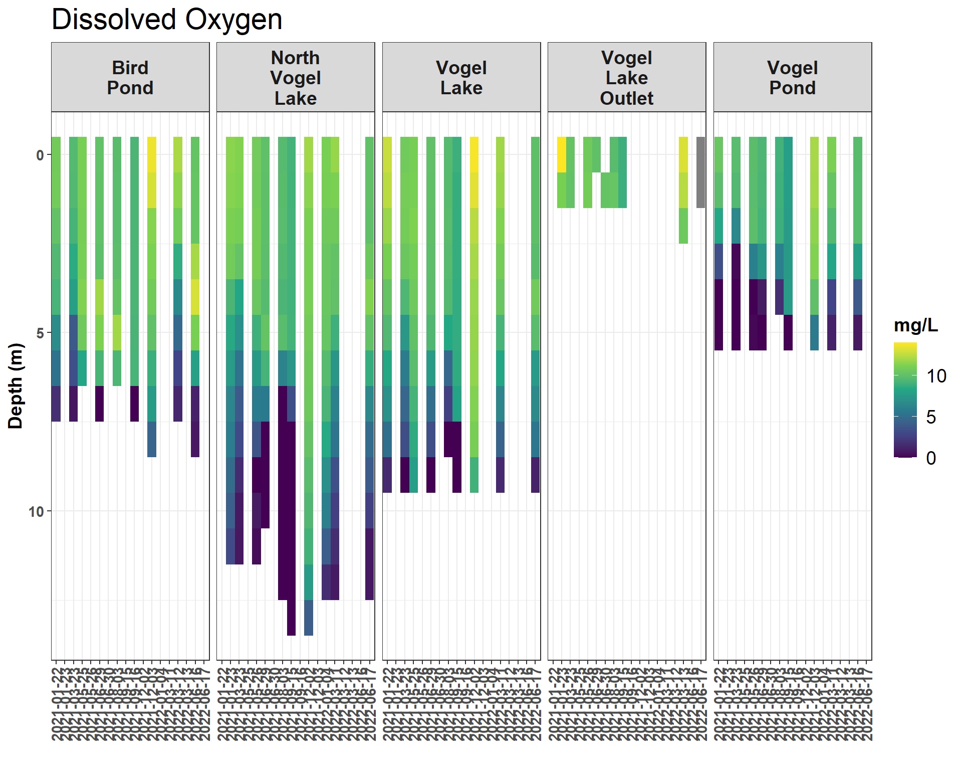

Figure 2.11: Dissolved Oxygen (mg/L)

#### 2.2.0.2 pH

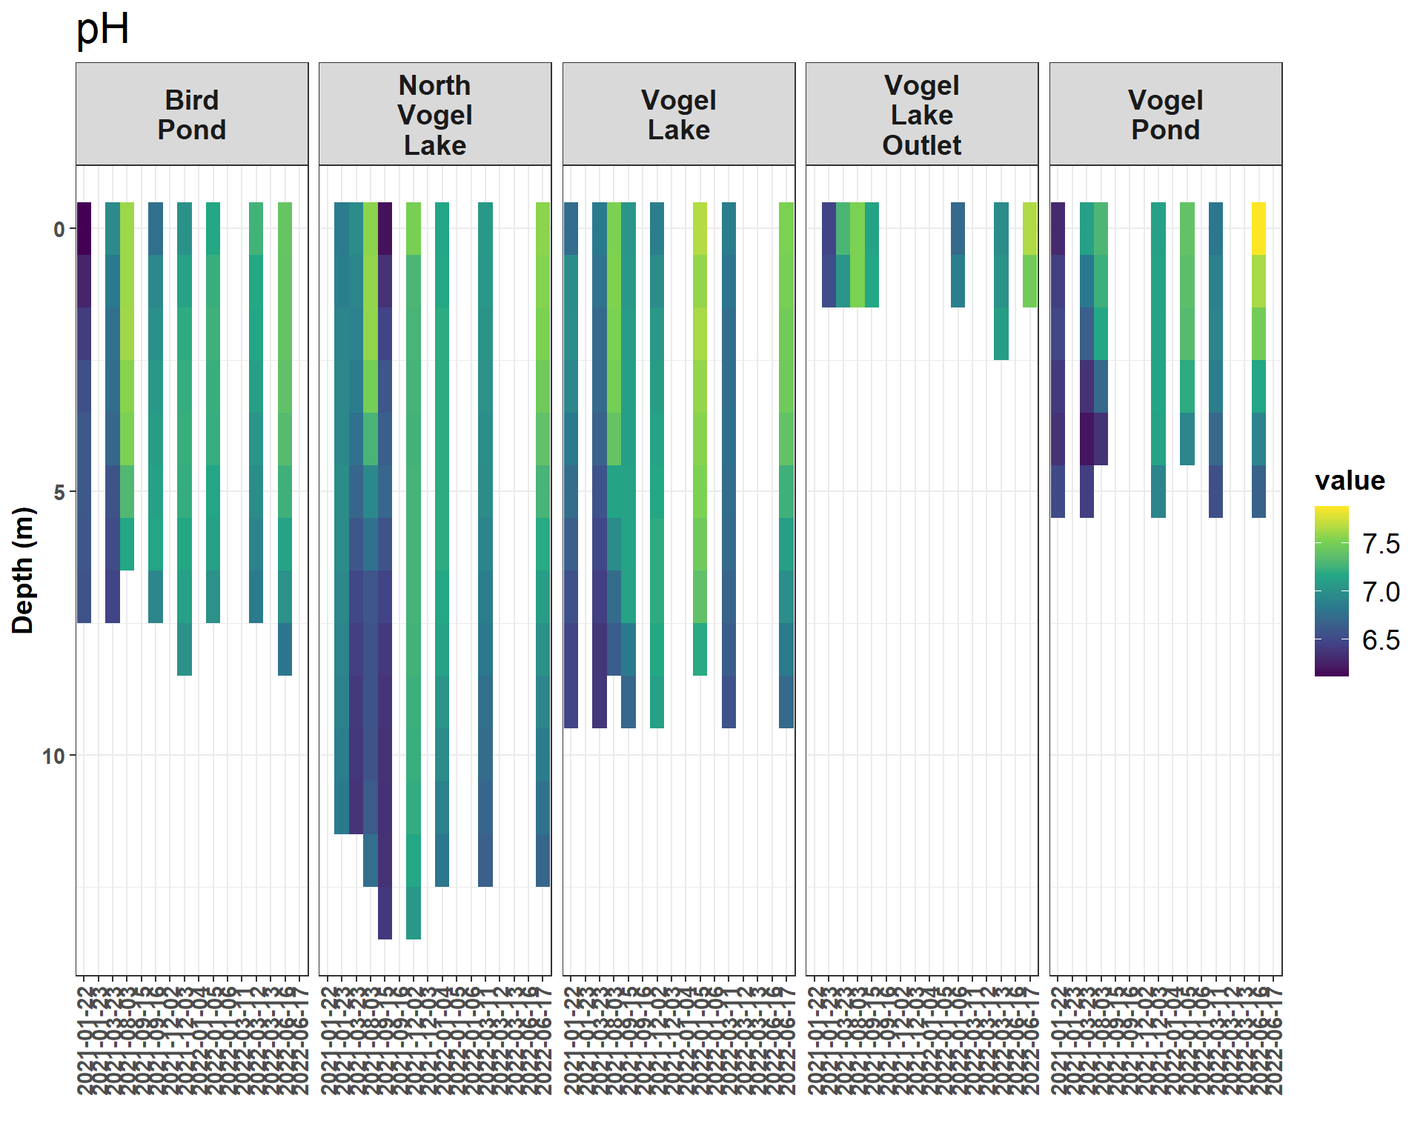

Figure 2.12: pH

Note: pH values are excluded from the May and June 2021 site visits due to an instrument error.

#### 2.2.0.3 Turbidity

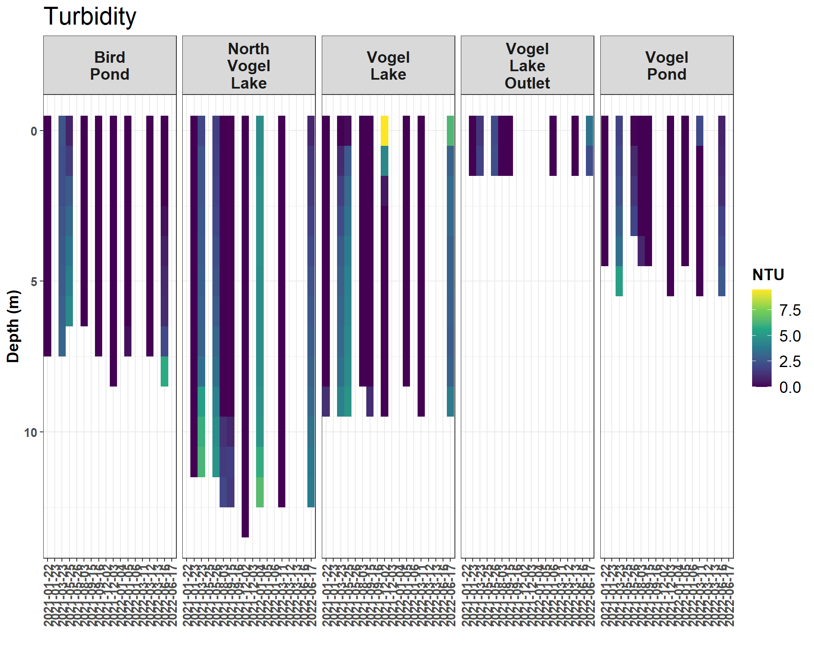

Figure 2.13: Turbidity (NTU)

Note: some turbidity values near the benthic surface of each site visit are not displayed in the above plot in order to improve visualization.

#### 2.2.0.4 Conductivity

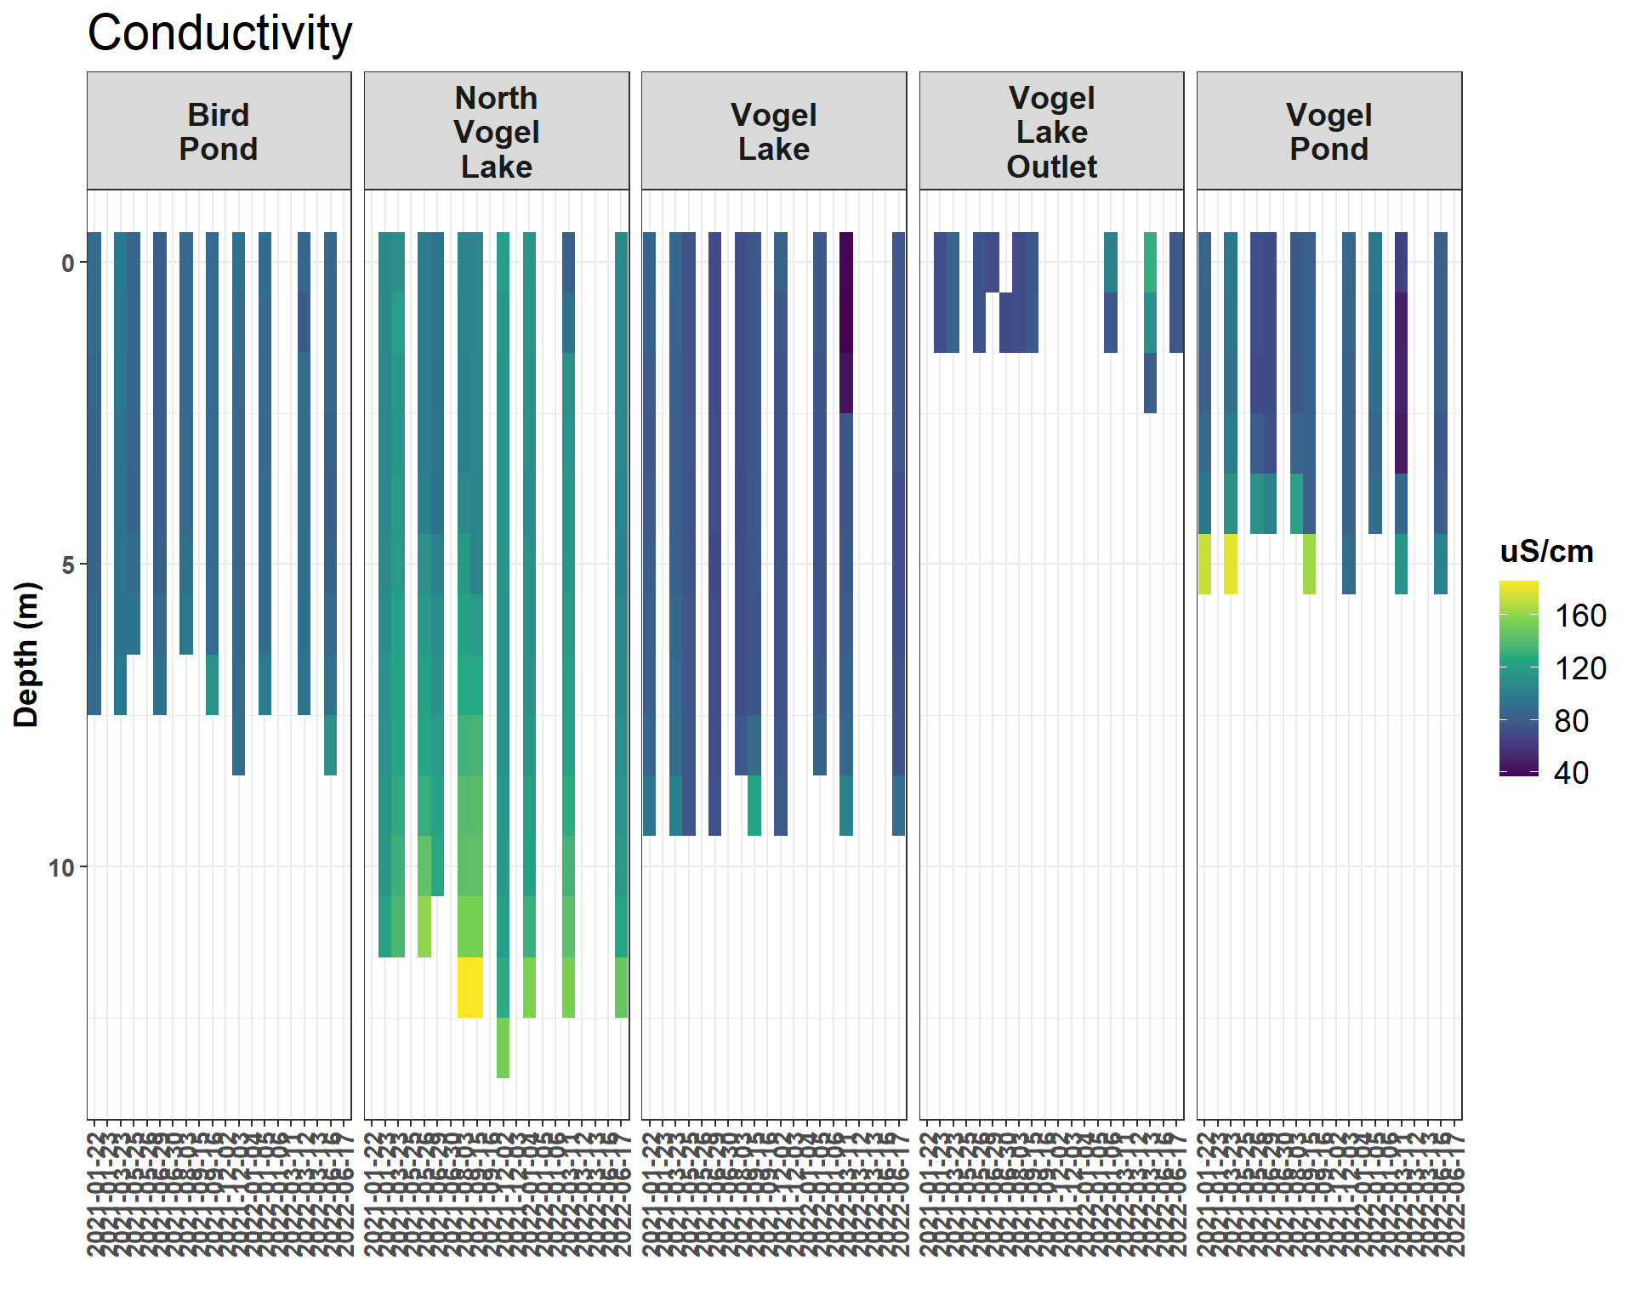

Figure 2.14: Conductivity (uS/cm)

Note: Conductivity values > 200 uS/cm are not shown in order to improve visualization. These values were found at the benthos of some water bodies.

#### 2.2.0.5 Water Temperature

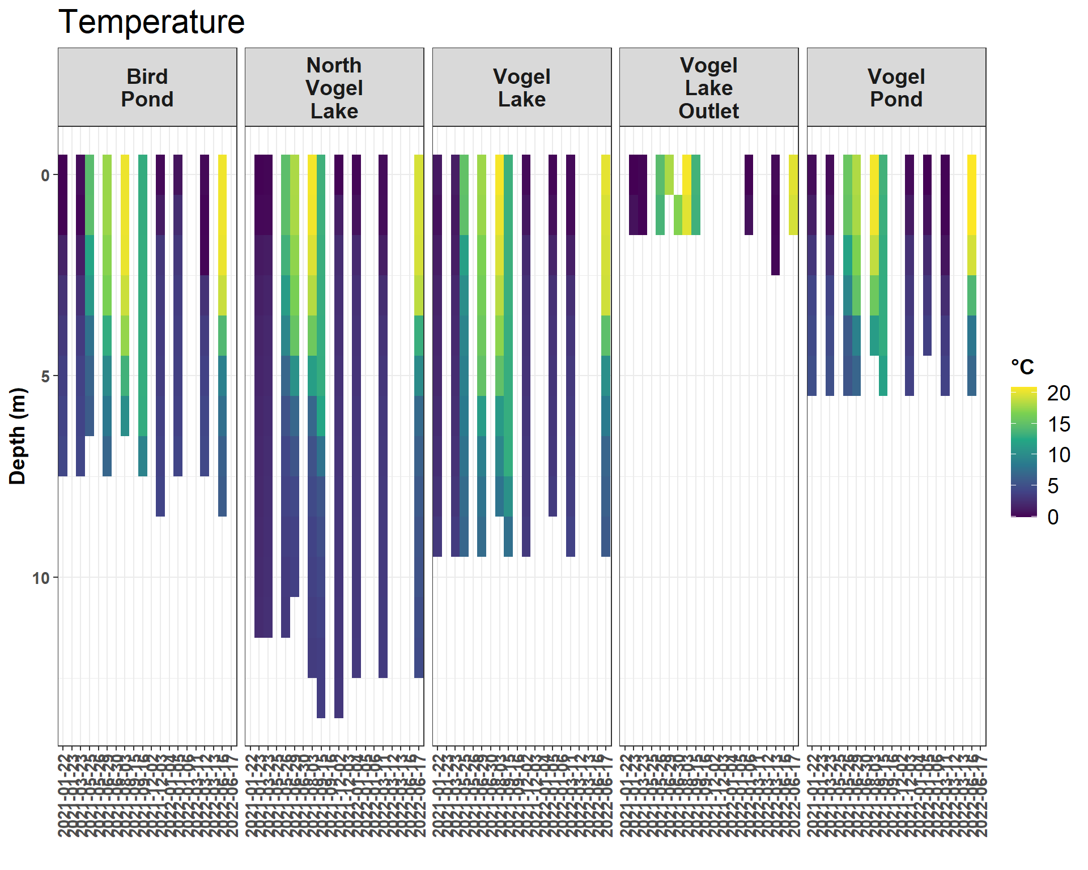

Figure 2.15: Water Temperature (C)

# 3 Miller Creek Discharge & Flow Rate

### 3.0.1 Introduction

Hydrology fieldwork focusing on flow and discharge is being conducted throughout the Miller Creek drainage in Fall 2020 - Spring 2021.

* Near the mouth of Miller Creek, a discharge measurement station was installed in October 2020. At this site a pressure transducer measures water level, and discharge measurements are collected periodically using a SondeTek FlowTracker Acoustic Doppler Velocimeter. These data, along with staff plate observations, are being used to create a rating discharge curve.
* An experiment to study stream flow rate in Miller Creek was conducted September 15-17, 2021. A plug of dissolved salt (NaCl) was discharged in to the creek, and the resultant spike in conductivity was observed downstream 0.64 km stream distance.

Raw water quality field data is stored in a Google Sheet that can be viewed at <https://tinyurl.com/kwf-vogel-wqx-data> under the “Discharge Measurements” tab.

Site photos are available through a point-and-click pop-up map at <https://arcg.is/0fqvb0>.

### 3.0.2 Methods

#### 3.0.2.1 Miller Creek Discharge Rating Curve

A discharge station was established in October 2020 near the mouth of Miller Creek, including a staff plate and Orpheus Mini pressure transducer.

Site visits were made opportunistically depending on precipitation throughout Summer/Fall 2021, and once each in Spring 2022 and Fall 2022. At each site visit, the pressure transducer is downloaded and a typically a discharge measurement is also collected using a SondeTek Flowtracker Acoustic Doppler Velocimeter. See Figure [3.1](https://bookdown.org/content/624941ef-f527-45ad-a026-e40be6fc5100/miller-creek-discharge-flow-rate.html#fig:ratingcurve1) for the discharge rates and staff plate values observed to date.

A total of seven discharge measurements at the Miller Creek mouth site were made between Fall 2020 and Spring 2022. A curve was fit to the scatter plot of stage height vs. discharge.

The rating curve for the outlet of Miller Creek and it’s source data may be accessed from the downloadable Excel file below:

[Download Miller Creek Outlet Rating Curve Data](https://github.com/Kenai-Watershed-Forum/Miller_Creek_Vogel_Lake_WQX/blob/cd5670bdd2fdeba535c55d902ad10fef5ee4d712/output/discharge_results/miller_creek_discharge.xlsx)

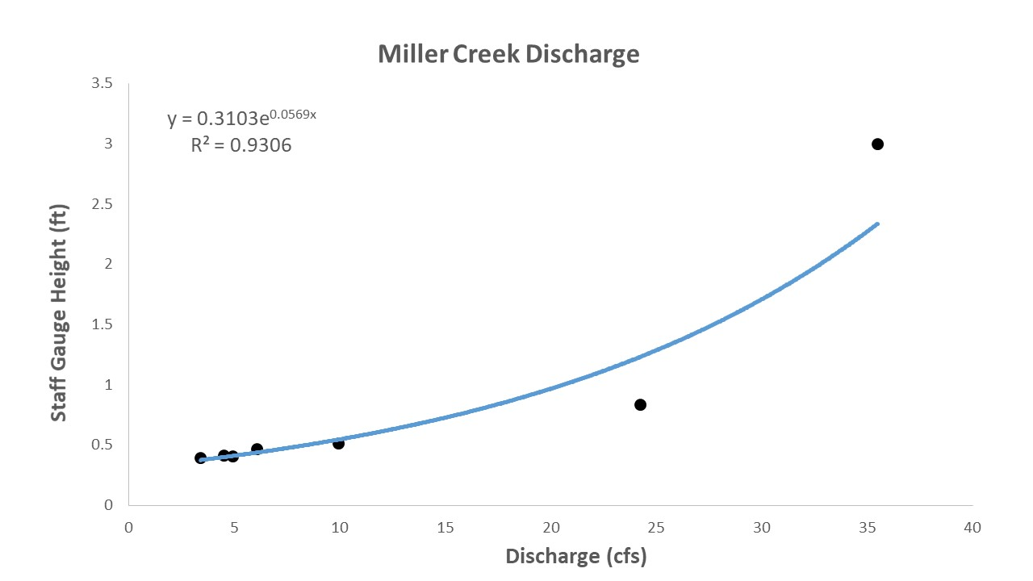

Figure 3.1: Miller Creek Discharge observations vs. Staff Gauge Height

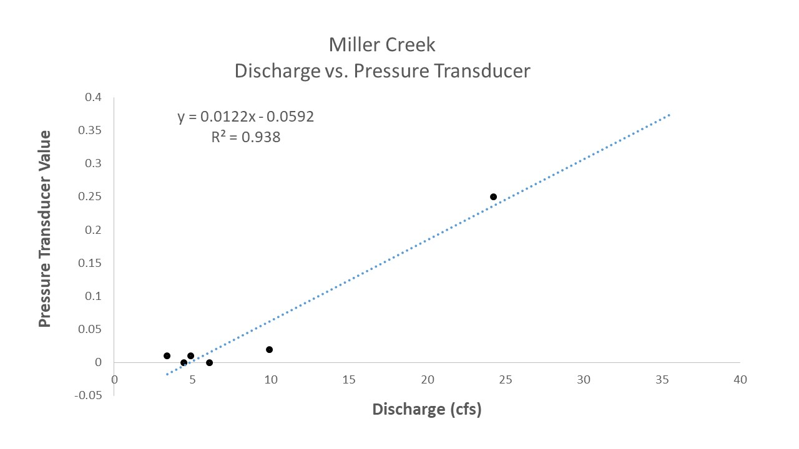

Figure 3.2: Miller Creek Discharge observations vs. Pressure Transducer Values

#### 3.0.2.2 Pressure Transducer Data

An Orpheus Mini pressure transducer (PT) was deployed at the mouth of Miller Creek from October 2020 through current day (as of 2022-10-10). Values were logged at 0.25 hr intervals.

We plotted staff plate observations with their simultaneous pressure transducer (PT) records and fit a linear regression. The resulting relationship (y = 0.0122x - 0.0592), where y is the PT value and x is stream discharge) can be used to translate the pressure transducer time series into a stream discharge time series, also known as a flow hydrograph ([3.2](https://bookdown.org/content/624941ef-f527-45ad-a026-e40be6fc5100/miller-creek-discharge-flow-rate.html#fig:ratingcurve2)) following the basic approach outlined in [Covino et al. 2020.](https://openecodatalab.github.io/Hydrology-Online/hydrology/7_rating_curve/7_rating_curve.html)

Notes and caveats on data inputs to the flow hydrograph for Miller Creek:

1. The quantity of paired discharge measurements and staff plate observations (7) is less than the minimum quantity desired (8) to record a rating curve.
2. The linear relationship does not meet assumptions of statistical normality typically applied for such circumstances. The low number of discharge observations is a result of the remote location of the project site and the challenging logistics required to visit. While additional field observations would create more precise discharge values, the general shape of the flow time series would remain unchanged.
3. Some pressure transducer time series data is either missing or should be excised for reasons including being affected by ice, exposure to air, or device removal due to concerns of site stability. Non-useful time periods are summarised in the downloadable table below.

[Download Download Miller Creek Pressure Transducer Data Missing / Excised Time Periods](https://github.com/Kenai-Watershed-Forum/Miller_Creek_Vogel_Lake_WQX/blob/main/output/discharge_results/miller_creek_discharge_excise.csv)

As of 2022-10-10, an insufficient number of discharge observations exist to make a reliable discharge rating curve for Miller Creek. As a result, the pressure transducer data in **[??](https://bookdown.org/content/624941ef-f527-45ad-a026-e40be6fc5100/miller-creek-discharge-flow-rate.html" \l "fig:ptdata)** is shown in raw form rather than as converted to stream discharge values.

Currently, available field observations produce a rating curve that translates to streamflow estimates ranging from 2.6 cfs to 187.3 cfs. These are likely an unreasonable estimate, given that the range of discharge values observed throughout the project (2021 - 2022) was between 4 cfs and 35 cfs.

Kenai Watershed Forum staff will continue to visit the site opportunistically throughout Summer 2023, and aim to gain sufficient discharge observations to create a reliable rating curve. We will consult with state and federal agency hydrologists to determine if alternative methods may be applied to develop a rating curve. These data may be useful in understanding management needs for potential future pike barriers.

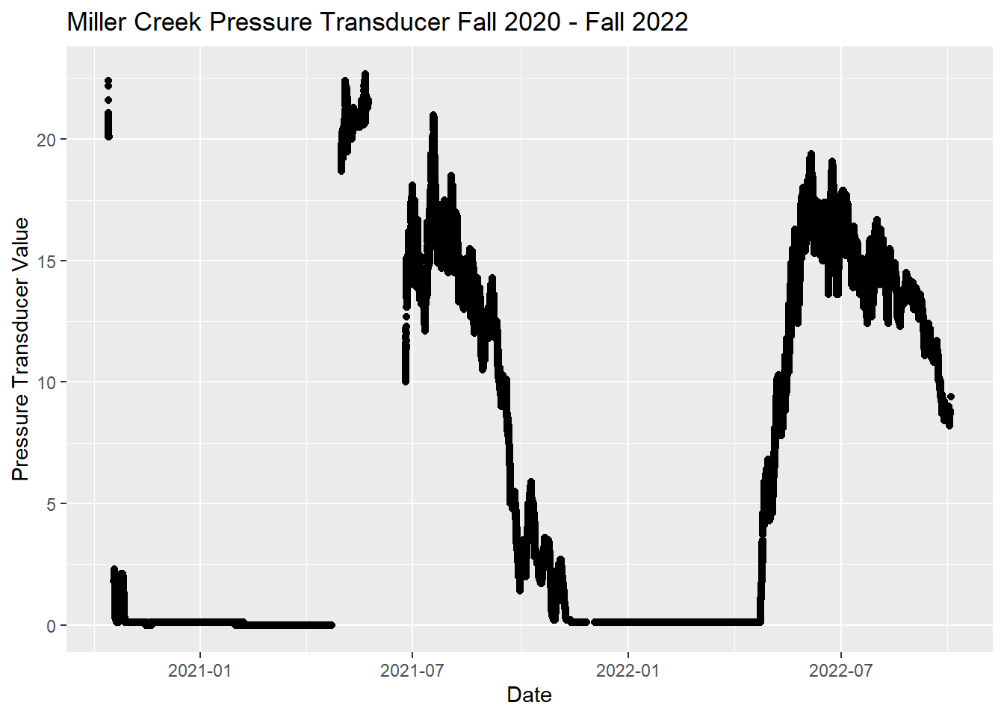

#### 3.0.2.3 Discharge measurements at other sites

Additional discharge measurements were taken throughout Summer 2021 at two additional sites near Vogel Lake, near the outlets of Kuguyuk Pond and Bird Pond. See Figure [3.3](https://bookdown.org/content/624941ef-f527-45ad-a026-e40be6fc5100/miller-creek-discharge-flow-rate.html#fig:other-discharge) for discharge values observed to date.

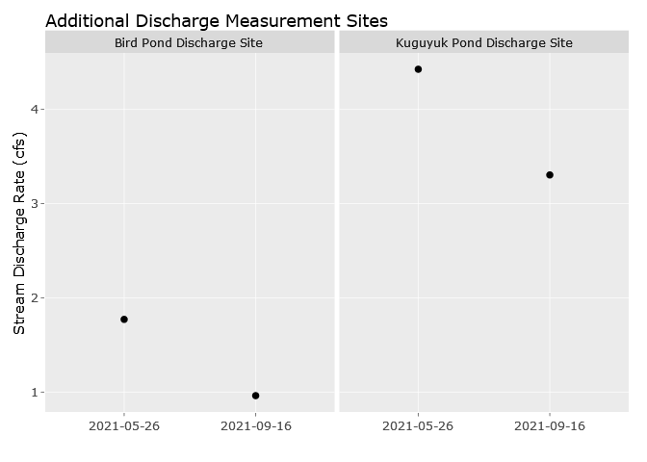

Figure 3.3: Other discharge measurements

#### 3.0.2.4 Stream Flow Rate Experiment

On September 15-17, 2021 we conducted an experiment to examine stream flow rate in Miller Creek. We measured downstream transport time of dissolved solutes by deploying a plug of dissolved salt and measuring a resultant change in conductivity at a site downstream. We deployed a plug of dissolved salt into the Miller Creek stream channel and measured conductivity continuously at a downstream site. See Figure [3.4](https://bookdown.org/content/624941ef-f527-45ad-a026-e40be6fc5100/miller-creek-discharge-flow-rate.html#fig:nacl-map) for salt deployment and conductivity monitoring sites.

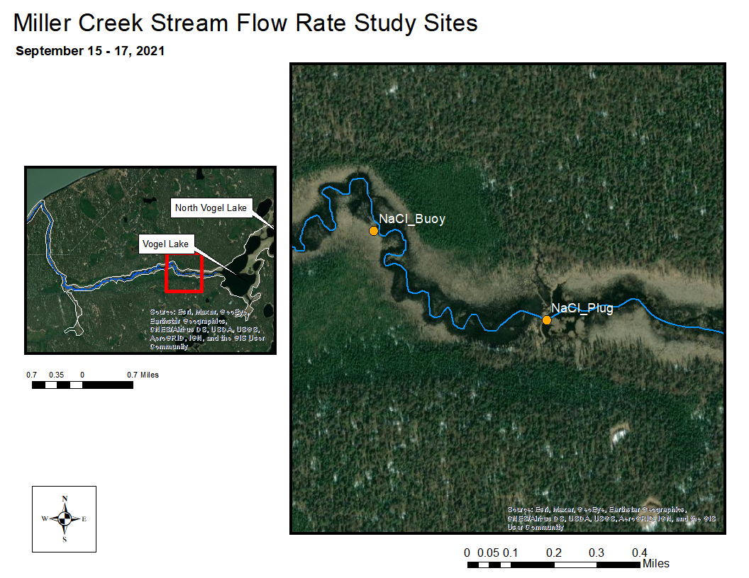

Figure 3.4: Stream Flow Rate Study Area. Stream distance between the NaCl release site and the downstream measurement site is 0.63 km (0.39 mi).

The Vogel Lake / Miller Creek system is a low-gradient drainage with little observable flow within 0.5 miles downstream of the lake outlet. We deployed our salt plug downstream from the Vogel Lake outlet at the first site with visibly evident surface flow, which was over the top of the first downstream beaver dam.

We released 140 lbs of dissolved NaCl by dissolving appx 15 lbs at a time in a 35 gallon trash can, then discharging it on the downstream side of the beaver dam into the stream channel. Our downstream site monitoring conductivity was 0.63 km (0.39 mi) downstream center-channel.

To record conductivity we used a pair of simultaneously deployed Hydrolab MS5 Sondes suspended from a floating buoy. We programmed the sondes to record at 0.25 hour intervals. We examined the resultant time series for exposure or errors and removed these data points. We averaged conductivity values between the two Hydrolab units in the final results.

##### 3.0.2.4.1 Streamflow Rate Results

We measured a readily evident rise in conductivity values at the downstream monitoring site. See Figure [3.5](https://bookdown.org/content/624941ef-f527-45ad-a026-e40be6fc5100/miller-creek-discharge-flow-rate.html#fig:nacl-fig) for the time series of conductivity data.

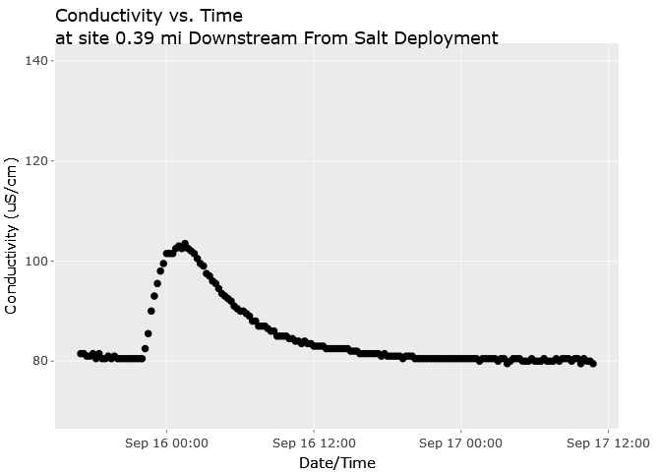

Figure 3.5: Conductivity values at the site downstream of the NaCl release site. The NaCl plug was released at 19:30 on 9/15/2021. The release and measurement site coordinates can be accessed at the ArcGIS Online Map at <https://arcg.is/0LqOKH0>.

In Figure [3.5](https://bookdown.org/content/624941ef-f527-45ad-a026-e40be6fc5100/miller-creek-discharge-flow-rate.html#fig:nacl-fig) we can observe the following:

* Initial NaCl Deployment: 9/15/2021 19:30
* Start of the rising limb of the conductivity spike: 9/15/2021 22:00 (2.5 hrs after deployment)
* Maximum conductivity peak (~20% above baseline values): 01:30 9/16/2021 (6.0 hours after deployment)
* Return to baseline conductivity levels: 9/16/2021 15:00 (19.5 hrs after deployment)

Based on these results, peak concentration of the dissolved solute traveled though this section of Miller Creek at **0.11 km/h (0.06 mph)**.

# 4 Watershed Mapping

* Watershed mapping efforts for this project include a combination of on the ground fieldwork and GIS based approaches.
* An ArcGIS Online interactive map outlining fieldwork sites and associated results is found at the following link: <https://arcg.is/0Djmay>
* Technicians walked the Miller Creek corridor on foot on May 27-28, 2021 to identify hydrologic features that may be difficult to identify from the air, such as seepages and springs. The locations are visible in the ArcGIS Online map in the “Hydrologic Connectivity” layer, and may be downloaded here as .gpx files:
  + All hydrologic features (n = 67): [miller_creek_features.gpx](https://drive.google.com/file/d/1PQu1v6nTD6MB3YStwBF3mgV0wydKziIa/view?usp=sharing)
  + Only seepage hydrologic features (n = 16): [miller_creek_seepage_features.gpx](https://drive.google.com/file/d/1_c4FQDR0t2sW_yphFuuiSpRmydPzjR3i/view?usp=sharing)

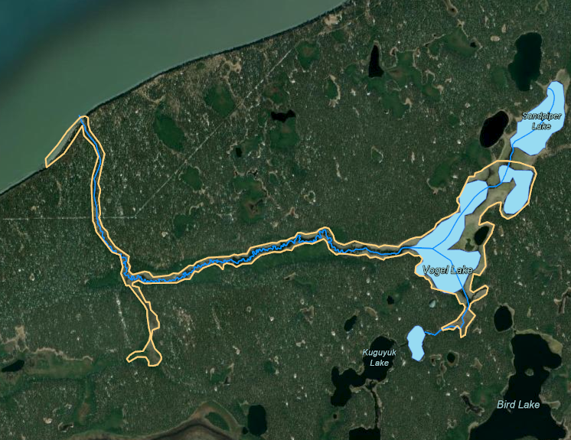

The seepage/spring hydrologic features were important to locate because of their potential to serve as refugia for invasive pike during the eradication process. These locations required special attention in order to ensure that rotenone permeated the watershed. However, the fieldwork of finding these locations was labor-intensive and prone to miss features that the human eye does not recognize

Future researchers tasked with identifying and locating such features may wish to consider using thermal infrared imagery (TIR). The technique has been successfully applied to identify thermal refugia for salmon in several Kenai Peninsula watersheds and helped develop empirically based land conservation priorities. The technique requires additional technical knowledge of remote sensing and GIS processing, but for large, remote projects where knowledge of such features is critical the technology may offer a much more robust methodology. See <https://inletkeeper.org/our-work/healthy-habitat/cold-water-refugia/> for more information.

# 5 Fish Rescue

## 5.1 Summary

On September 27-29, 2021, staff from Kenai Watershed Forum and Cook Inlet Aquaculture Association led fish rescue efforts in Lower Miller Creek prior to rotenone treatment. We used minnow traps to capture juvenile fish, which were later transported by helicopter to Bird Pond for winter residency until post-treatment rotenone levels decrease to safe levels. A fish barrier currently at the outlet of Bird Pond will be removed in Summer 2022 pending confirmation of safe conditions.

## 5.2 Methods

We captured juvenile fish in the segment of Miller Creek extending from it’s mouth at Cook Inlet to a location upstream approximately 1.3 km from the mouth, N 60.99530, W -150.50760.

We used Gee minnow traps baited with cured, disinfected salmon eggs. We placed eggs placed inside perforated canisters to prevent consumption by the fish. We placed minnow traps in locations known to be preferred by juvenile salmonids, including areas with woody debris, pools, and areas with riparian cover. We deployed traps for time periods of 6-12 hours at a time, and returned with all captured fish in five-gallon buckets to a central location. We identified all captured fish to genus or species for the purpose of ensuring that no juvenile pike were included in the captured population.

After identifying fish taxa, we stored juvenile fish in three perforated five gallon buckets submerged within the creek on site. We placed stones at the bottom of each bucket to keep them submerged. These fish were stored until being retrieved by helicopter for transport to Bird Lake on 10/1/2021.

## 5.3 Results

| Table 5.1: Minnow trap deployment and fish capture, estimated data from Lower Miller Creek | | | |
| --- | --- | --- | --- |
| **Deployment_Date_Time** | **Retrieval_Date_Time** | **Trap_Count** | **Fish_Capture** |
| 2021-09-27 18:15:00 | 2021-09-28 10:00:00 | 48 | 400 |
| 2021-09-28 12:00:00 | 2021-09-28 18:00:00 | 48 | 150 |
| 2021-09-28 18:30:00 | 2021-09-29 09:00:00 | 30 | 75 |

Table [5.1](https://bookdown.org/kwfwqx/miller_creek_vogel_lake_wqx/fish-rescue.html#tab:rescue-tbl) summarizes capture and effort data for fish rescue efforts in Lower Miller Creek. Due to limited available staff as a result of the COVID-19 pandemic, minimal formal data on fish capture was recorded in order to focus primarily on maximizing the quantity of fish captured prior to rotenone treatment. As a result, values in table [5.1](https://bookdown.org/kwfwqx/miller_creek_vogel_lake_wqx/fish-rescue.html#tab:rescue-tbl) are estimates rather than exact quantities.

Fish captured from Lower Miller Creek were identified to species by ADF&G staff prior to placement into Bird Pond, although these fish were not segregated from fish also captured in the Vogel Lakes complex and Upper Miller Creek. Table [5.2](https://bookdown.org/kwfwqx/miller_creek_vogel_lake_wqx/fish-rescue.html#tab:spp-tbl) provides total capture counts for fish rescue efforts throughout the Miller Creek/Vogel Lakes complex.

| Table 5.2: Fish capture data from Lower Miller Creek | | |
| --- | --- | --- |
| **Species** | **N** | **Notes** |
| Rainbow Trout | 330 | Primarily mature adults |
| Coho Salmon | 406 | Primarily juveniles, a few that were likely landlocked adults |
| Sockeye Salmon | 5 | NA |
| Sculpin | 92 | NA |

## 5.4 Photos

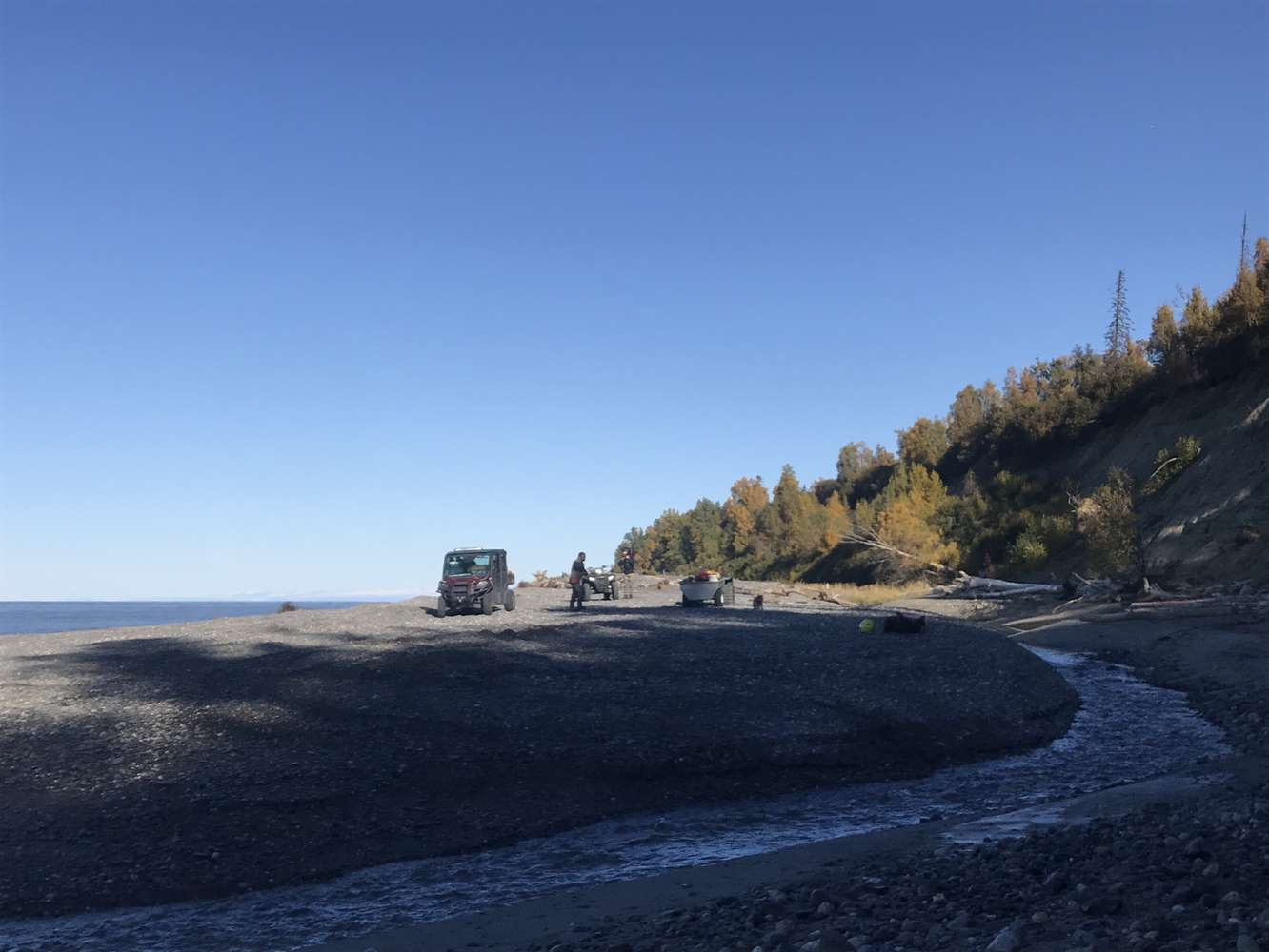

Figure 5.1: Mouth of Miller Creek

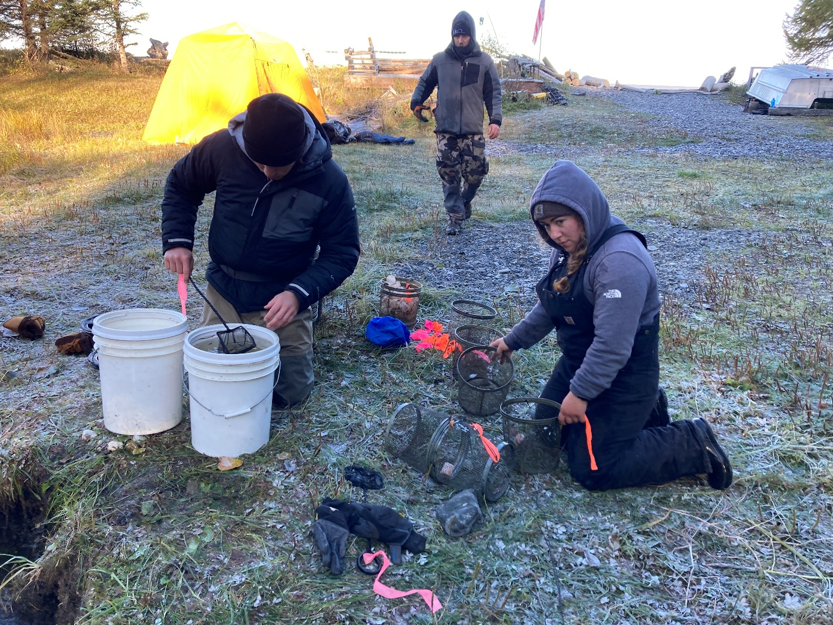

Figure 5.2: Fish processing site

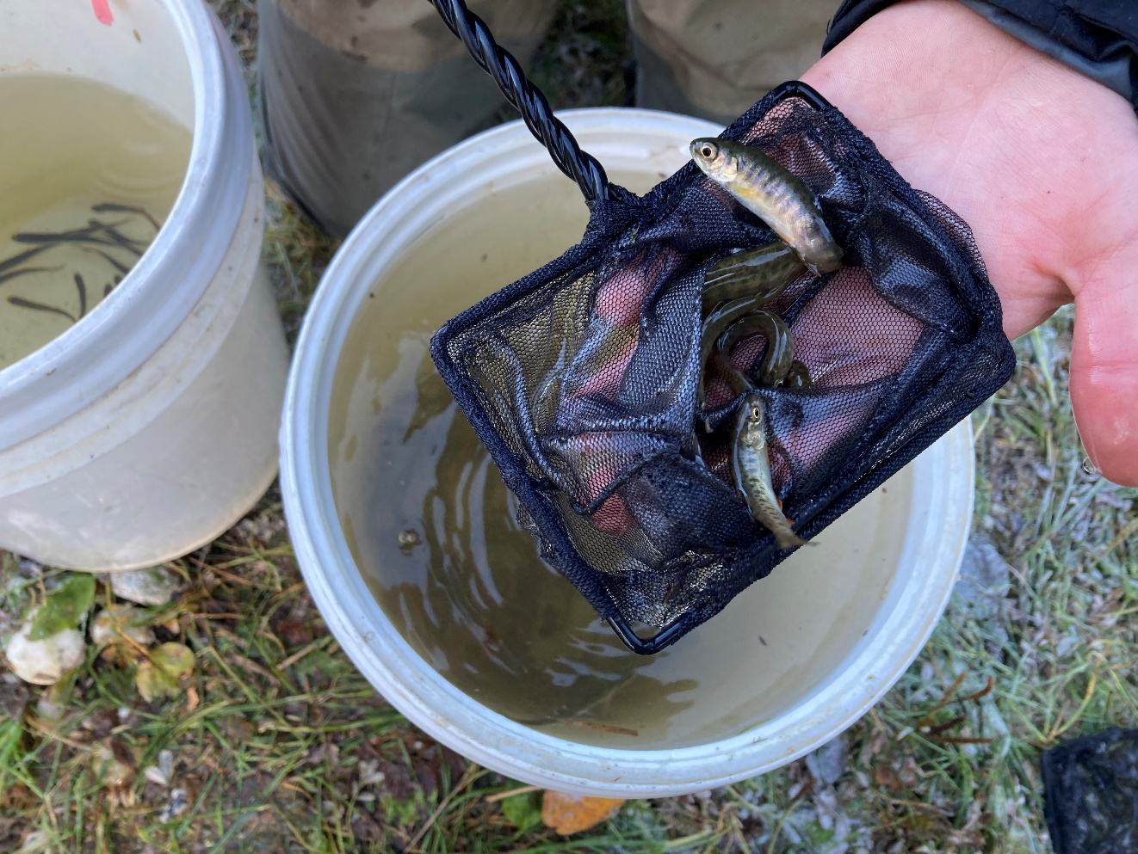

Figure 5.3: Juvenile Coho Salmon

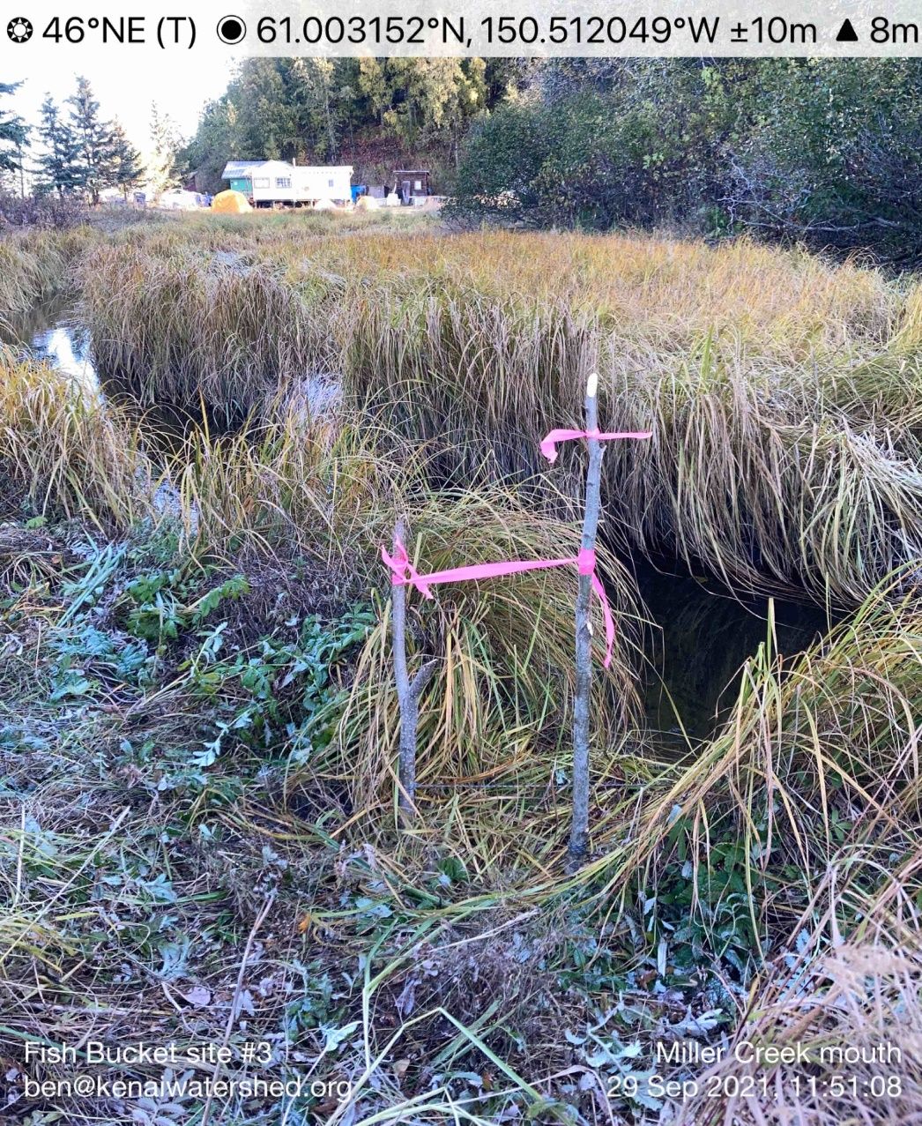

Figure 5.4: Site for storage of perforated five-gallon bucket to store juvenile fish

# 6 Rotenone monitoring

Rotenone application was performed in early October 2021 by ADF&G staff. The treated bodies of water included Vogel Lake, North Vogel Lake, and Miller Creek. ADF&G collected pre and post-treatment water samples as part of the treatment event, and Kenai Watershed Forum monitored degradation through Summer 2022 when levels fell to undetectable.

Field sampling and analytical methods generally followed those described in [Couture et al. 2022](https://www.sciencedirect.com/science/article/pii/S0045653521029507?casa_token=ay4PaETNCSQAAAAA:_IZ-AVNjAqJ4cdwnVLYAoXmbG5KvzPbpQ8aTeu54QqIzDietLnk1Xe_uj5z93IzrNsoCRwsSOaM). Prior to rotenone treatment, we collected a composite grab sample from two locations at a depth of 0.5 m near the center of each lake. Following treatment, we collected lake water samples at a depth of 0.5 m from two locations around the center of the lake either as a grab sample or with a Kemmerer sampler. For each strata of each lake, a single composite sample was created from the two locations. For benthic samples, the Kemmerer sampler was lowered to a depth within 2 m from the bottom in the same two locations around the center of the lake. The collected water from two locations was then combined into a single 1 L composite sample. All samples were collected into sterilized 1 L amber glass bottles, immediately chilled on ice, stored out of the light and transported to the Applied Science, Engineering and Technology (ASET) Lab located at the University of Alaska Anchorage (UAA) within 72 h of collection. Upon arrival to the lab all samples were stored in the dark at 4°C and analyzed via high performance [liquid chromatography](https://www.sciencedirect.com/topics/earth-and-planetary-sciences/liquid-chromatography) tandem mass spectrometry (HPLC-MS/MS) within seven days of collection.

## 6.1 Sampling schedule

The rotenone sampling schedule is described in table [6.1](https://bookdown.org/kwfwqx/miller_creek_vogel_lake_wqx/rotenone-monitoring.html#tab:sample-schedule) or may be accessed in a Google Sheet linked here: <https://tinyurl.com/8ba94nrn>. The schedule is current as of 2022-10-10.

| Table 6.1: Vogel lake and Miller Creek rotenone sampling schedule | | | | | | | |
| --- | --- | --- | --- | --- | --- | --- | --- |
| **Field Sample Count** | **Field Sample Date** | **Status** | | **Location** | **Depth** | **Notes** |
| 1 | 2021-09-27 | Complete | Vogel Lake | | Surface | Pre-treatment |
| 1 | 2021-09-28 | Complete | North Vogel Lake | | Surface | Pre-treatment |
| 1 | 2021-10-07 | Complete | Vogel Lake | | Surface |  |
| 1 | 2021-10-07 | Complete | Vogel Lake | | Benthic |  |
| 1 | 2021-10-07 | Complete | North Vogel Lake | | Surface |  |
| 1 | 2021-10-07 | Complete | North Vogel Lake | | Benthic |  |
| 1 | 2021-10-08 | Complete | Miller Creek Head | | Surface |  |
| 1 | 2021-11-10 | Complete | Miller Creek Weir | | Surface |  |
| 1 | 2021-11-10 | Complete | North Vogel Lake | | Surface | Alternative sampling location due to thin ice |
| 1 | 2021-11-10 | Complete | Vogel Lake | | Surface | Alternative sampling location due to thin ice |
| 1 | 2021-12-03 | Complete | Miller Creek | | Surface |  |
| 1 | 2021-12-02 | Complete | North Vogel Lake | | Surface |  |
| 1 | 2021-12-02 | Complete | Vogel Lake | | Surface |  |
| 1 | 2021-12-03 | Complete | Miller Creek | | Benthic |  |
| 1 | 2021-12-02 | Complete | North Vogel Lake | | Benthic |  |
| 1 | 2021-12-02 | Complete | Vogel Lake | | Benthic |  |
| 1 | 2022-01-05 | Complete | Miller Creek | | Surface |  |
| 1 | 2022-01-05 | Complete | North Vogel Lake | | Surface |  |
| 1 | 2022-01-05 | Complete | Vogel Lake | | Surface |  |
| 1 | 2022-02-04 | Complete | North Vogel Lake | | Benthic |  |
| 1 | 2022-02-04 | Complete | North Vogel Lake | | Surface |  |
| 1 | 2022-02-04 | Complete | Vogel Lake | | Surface | Surface location A |
| 1 | 2022-02-04 | Complete | Vogel Lake | | Surface | Surface location B |
| 1 | 2022-03-11 | Complete | North Vogel Lake | | Benthic |  |
| 1 | 2022-03-11 | Complete | North Vogel Lake | | Surface |  |

## 6.2 Rotenone sampling map

Access the online map at https://arcg.is/1GeLTX. The map layer titled "Rotenone Sampling" contains interactive click-able points with sampling details including coordinates. Site coordinates can be accessed at <https://tinyurl.com/kwf-vogel-wqx-data>.

[](https://arcg.is/1GeLTX)

## 6.3 Rotenone concentration results

### 6.3.1 Sample results

#### 6.3.1.1 Tables

Laboratory analysis of water samples was performed by the [ASET Laboratory](https://www.uaa.alaska.edu/academics/college-of-arts-and-sciences/departments/chemistry/aset_lab/) at the University of Alaska Anchorage Department of Chemistry in Anchorage, Alaska. Detailed analytical methods can be found in [Couture et al. 2022](https://www.sciencedirect.com/science/article/pii/S0045653521029507?casa_token=ay4PaETNCSQAAAAA:_IZ-AVNjAqJ4cdwnVLYAoXmbG5KvzPbpQ8aTeu54QqIzDietLnk1Xe_uj5z93IzrNsoCRwsSOaM).

Original results received from UAA are available for download at the following link:

* [Link: Rotenone Degradation Laboratory Results](https://github.com/Kenai-Watershed-Forum/Miller_Creek_Vogel_Lake_WQX/tree/main/input/rotenone_data).

A table of final results that have been integrated into a single dataframe and reshaped to a “long” format are available for download at the the following link:

* [Link: Rotenone Degradation Final Results](https://github.com/Kenai-Watershed-Forum/Miller_Creek_Vogel_Lake_WQX/tree/main/output/rotenone_results)

A summarised version of the above downloadable table is displayed in Table [6.2](https://bookdown.org/kwfwqx/miller_creek_vogel_lake_wqx/rotenone-monitoring.html#tab:rotenone-table). Values shown in Table [6.2](https://bookdown.org/kwfwqx/miller_creek_vogel_lake_wqx/rotenone-monitoring.html#tab:rotenone-table) are averages of duplicate lab values (overall mean percent difference = 1.25 ± 2.44 %, mean ± SD).

| Table 6.2: Rotenone results. See above download link for complete analysis results, including other parameters (rotenolone, deguelin, and others.) | | | | | |
| --- | --- | --- | --- | --- | --- |
| **sample_name** | **field_sample_date** | **waterbody** | **strata** | **rotenone_ppb** | **detection_note** |
| Miller Creek Weir | 2021-11-10 | Miller_Creek | Creek | 2.010 |  |
| Miller_Creek_1 | 2021-10-08 | Miller_Creek | Creek | 22.960 |  |
| Miller_Creek_2 | 2021-12-03 | Miller_Creek | Creek | 6.585 |  |
| Miller_Creek_2 | 2022-01-05 | Miller_Creek | Creek | 0.000 | value <0.5 ppb |
| N_Vogel_Benthic | 2021-10-07 | N_Vogel_Lake | Benthic | 13.605 |  |
| N_Vogel_Benthic | 2021-12-02 | N_Vogel_Lake | Benthic | 12.280 |  |
| N_Vogel_Benthic | 2022-01-05 | N_Vogel_Lake | Benthic | 8.755 |  |
| N_Vogel_Benthic | 2022-02-02 | N_Vogel_Lake | Benthic | 0.000 | Not_Detected |
| N_Vogel_Benthic | 2022-03-11 | N_Vogel_Lake | Benthic | 0.000 | Not_Detected |
| N_Vogel_Surface | 2021-09-28 | N_Vogel_Lake | Surface | 0.000 | Not_Detected |
| N_Vogel_Surface | 2021-10-07 | N_Vogel_Lake | Surface | 26.900 |  |
| N_Vogel_Surface | 2021-11-10 | N_Vogel_Lake | Surface | 15.335 |  |
| N_Vogel_Surface | 2021-12-02 | N_Vogel_Lake | Surface | 13.710 |  |
| N_Vogel_Surface | 2022-01-04 | N_Vogel_Lake | Surface | 9.000 |  |
| N_Vogel_Surface | 2022-02-02 | N_Vogel_Lake | Surface | 8.765 |  |
| N_Vogel_Surface | 2022-03-11 | N_Vogel_Lake | Surface | 0.000 | Not_Detected |
| Vogel_Benthic | 2021-10-07 | Vogel_Lake | Benthic | 18.555 |  |
| Vogel_Benthic | 2021-12-02 | Vogel_Lake | Benthic | 10.715 |  |
| Vogel_Benthic | 2022-01-05 | Vogel_Lake | Benthic | 0.000 | Not_Detected |
| Vogel_Surface | 2021-09-27 | Vogel_Lake | Surface | 0.000 | Not_Detected |
| Vogel_Surface | 2021-10-07 | Vogel_Lake | Surface | 25.355 |  |
| Vogel_Surface | 2021-11-10 | Vogel_Lake | Surface | 12.735 |  |
| Vogel_Surface | 2021-12-02 | Vogel_Lake | Surface | 8.810 |  |
| Vogel_Surface | 2022-01-05 | Vogel_Lake | Surface | 0.000 | Not_Detected |
| Vogel_Surface | 2022-02-02 | Miller_Creek | Creek | 0.000 | Not_Detected |

#### 6.3.1.2 Figures

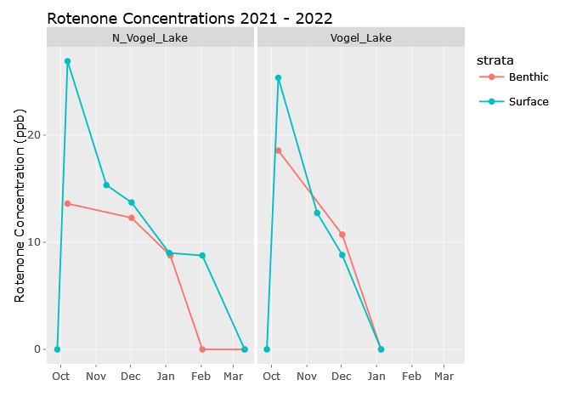

Figure 6.1: Average rotenone concentrations in Vogel Lake and North Vogel Lake, Fall 2021 through Spring 2022.

**Note on Miller Creek results:**

* Rotenone values for Miller Creek are not shown in a continuous time series figure due to more limited sample results from varying locations. See Table [6.2](https://bookdown.org/kwfwqx/miller_creek_vogel_lake_wqx/rotenone-monitoring.html#tab:rotenone-table) for results from Miller Creek.

# 7 Hydrolab Data

Hydrolab data is not published here. For more details and for access to hydrolab data from this site contact Kenai Watershed Forum at [*hydrology@kenaiwatershed.org*](mailto:hydrology@kenaiwatershed.org) or call the office at (907) 262-5449.

To assess variation in water quality throughout time, two OTT Hydrolab MS5 multiparameter water quality sondes (“Hydrolabs”) were deployed at the inlet of Miller Creek where it exits Vogel Lake in summer 2021 and summer 2022. The pair of Hydrolabs were placed in the center of the stream midway through the water column suspended from a buoy. Prior to deployment, all Hydrolabs were calibrated in accordance with the Department of Environmental Conservation (DEC)-approved Quality Assurance Project Plan: Kenai River Watershed Monitoring Program requirements ([KWF, 2019](https://paperpile.com/app/p/7703451b-460d-00b4-82a0-1086ea2554c3)). Post-retrieval, Hydrolabs underwent quality assurance checks for all parameters assessed in the field. Prior to departure, quality control measures were taken to ensure proper data collection including cleaning of Hydrolabs and ensuring the use of calibration solutions prior to expiration dates.

Hydrolab data were assessed in Fall 2022. Parameters included temperature, pH, dissolved oxygen, conductivity, turbidity, and temperature. Results were found to be of mixed reliability for characterizing water quality at this site. Due to the site’s remote location and the low flow rate in Miller Creek, the schedule necessary to maintain the hydrolabs (probe cleaning, battery replacement, calibration) was not maintained on a schedule that would be standard practice at a road accessible site. As a result, hydrolab data at this site is not published in this report. Some parameters (e.g. temperature) yielded more consistently reliable data than others that employed probes which may have seen some algae growth (e.g. turbidity). For more details and for access to hydrolab data from this site, contact Kenai Watershed Forum at [hydrology@kenaiwatershed.org](mailto:hydrology@kenaiwatershed.org) or call their office at (907) 262-5449.

# 8 Discussion and Acknowledgements

#### 8.0.0.1 Discussion

The work presented in this report is the result of collaboration between Kenai Watershed Forum (KWF) and the inter-agency team tasked with managing invasive pike in the Vogel Lake / Miller Creek system. The collaboration yielded readily applicable data, and may serve as an example of a productive hands-on relationship between agencies and nonprofits.

To develop this project, the Soldotna Office of the Alaska Department of Fish and Game worked with KWF in 2019 to submit a grant submission to the National Fish and Wildlife Association, which was funded in Fall 2020. Initial work in Fall 2020 consisted of establishing the flow discharge site near the mouth of Miller Creek. Beginning in January, KWF visited Vogel Lake in approximately every other month throughout 2021, with frequency of site visits tapering throughout 2022.

These data may be revisited and analyzed in more detail if future work in the area requires baseline water quality data. For example, an ongoing discussion among agency staff has the potential to result in the installation of a selective fish passage barrier to mitigate the potential for future upstream pike movement.

#### 8.0.0.2 Acknowledgements

Many individuals and organizations contributed to making this work possible, including but not limited to:

* Alaska West Air
* Alaska Department of Fish and Game
* Kenai National Wildlife Refuge
* Rob Massengill
* Ben Wishnek
* Stephen Miller
* Dr. Zach Redman and Dr. Pat Tomco (UAA ASET Lab)
* Andy Wizik (Cook Inlet Aquaculture Association)
* Kenny Rogers

Kenai Watershed Forum Personnel

* Maggie Harings
* Branden Bornemann
* Rhonda McCormick
* Jack Buban
* Chelsea Wisotzkey
* Judah Eason
* Megan Pike
* Maura Schumacher
* Brandon Drzazgowski
* Galen Hecht

**References**

Couture, J.M., Redman, Z.C., Bozzini, J., Massengill, R., Dunker, K., Briggs, B.R., and Tomco, P.L. 2021. Field and laboratory characterization of rotenone attenuation in eight lakes of the Kenai Peninsula, Alaska. Chemosphere **288**(Pt 2): 132478.

Covino, T., Emanuelson, K., and Rhea, A. (n.d.). Hydrographs & Rating Curves. Available from https://openecodatalab.github.io/Hydrology-Online/hydrology/7_rating_curve/7_rating_curve.html [accessed 10 October 2022].